

**Monash University**

**FIT 3164 Code Report**

**Group 13**

**Members:**

**Haoying Zhang 27791912**

**Haoyang Zheng 28764838**

**Xiaoran Gui 27178234**

**Code for personal development** **3**

**Code for Shiny Application** **13**

Ui interface: 13

Main.R: 14

Server.R 15

**System consideration** **25**

**Limitations and potential improvement** **28**

**End user guide on the shiny app** **29**

**Technical User Guide** **47**

# Code for personal development

(Important Note!)

(If running this code on personal laptops, please change the working directories to suitable places)

(All setwd(“directory”) only works on our teams computer, anything before /FIT3164S2/XXXX will not work therefore it needs to be changed.)

(Also, the testingShp.tif is also provided in the FIT3164S2 under the QGIS folder)

**library**(raster)

**library**(rgdal)

**library**(spatialEco)

**library**(plyr)

**library**(dplyr)

**library**(sp)

*#Above are the libraries that will be needed#*

*#If any are missing, Rstudio will automatically remind the user to download them#*

*###########################################################*

*#Personal computer, setting the directory where the VBA data is##*

**setwd**("/Users/leozhang/Desktop/FIT3164S2/Rdata")

data = **read.csv**("VBA.csv")

*#############################Function#######################*

*#Add raster Function*

addRaster <-**function**(data)

{

**setwd**("/Users/leozhang/Desktop/FIT3164S2/Rdata/Raster")

*#Above is the directory where all the rasters are*

*#These are all the raster files*

test = **raster**("75m_dem_streams_burned_sept2012")

test2 = **raster**("log_vertical_distance_saline_wetlands_sept2012")

test3 = **raster**("sept2014JanRainfall")

test4 = **raster**("Radiometrics_2014_k")

test5 = **raster**("Radiometrics_2014_th")

test6 = **raster**("vegtype3_4")

test7 = **raster**("Anisotrophic_Heating_Ruggedness")

test8 = **raster**("sept2014JanMaxTemp")

test9 = **raster**("ecoregion2014")

test10 = **raster**("wetness_index_saga_sept2012")

test11 = **raster**("sept2014JulMinTemp")

test12 = **raster**("land_cov_use3")

*#Creating raster stack*

rasStack = **c**(test,test2,test3,test4,test5,test6,test7,test8,test9,test10,test11,test12)

*#turning the normal data frame into a spatial data frame*

**coordinates**(data) = **~**LONGITUDEDD_NUM **+** LATITUDEDD_NUM

*#proj4string(data) = crs("+proj=longlat +datum=WGS84 +no_defs +ellps=WGS84 +towgs84=0,0,0")*

**proj4string**(data) = **crs**("+proj=longlat +datum=WGS84")

newproj = "+proj=lcc +lat_1=-38 +lat_2=-36 +lat_0=-37 +lon_0=145 +x_0=2500000 +y_0=2500000 +datum=WGS84 +units=m +no_defs

+ellps=WGS84 +towgs84=0,0,0"

*#reprojecting the VBA data to a new projection.*

newspdf = **spTransform**(data, newproj)

*#data = spTransform(data, newproj)*

combinePointValue = data

*#Extracting the raster data out to combine with the VBA data*

**for** (val **in** rasStack) {

rS = **stack**(val)

rasValue = **extract**(rS,newspdf)

combinePointValue = **cbind**(combinePointValue,rasValue)

}

*#Turn it back into a normal data frame*

data = **as.data.frame**(combinePointValue)

*#return the data*

**return**(data)

}

*#########################################################*

*#Adding shape file data*

addShp <-**function**(data)

{

*#Directory where the shape files are*

**setwd**("/Users/leozhang/Desktop/FIT3164S2/Rdata/Raster")

buashape = **readOGR**("VMLITE_BUILT_UP_AREA.shp")

forestshape = **readOGR**("VMLITE_FOREST_SU5.shp")

watershape = **readOGR**("VMLITE_HY_WATER_AREA.shp")

*#Transforming the projection to the longitude and latitude*

buashape1 = **spTransform**(buashape, **CRS**('+proj=longlat +datum=WGS84'))

forestshape = **spTransform**(forestshape, **CRS**('+proj=longlat +datum=WGS84'))

watershape = **spTransform**(watershape, **CRS**('+proj=longlat +datum=WGS84'))

*#Turn into spatial data frame*

**coordinates**(data) = **~**LONGITUDEDD_NUM **+** LATITUDEDD_NUM

**proj4string**(data) = **crs**("+proj=longlat +datum=WGS84")

*#Extract the information on the points of the VBA data on the shape file*

test = **extract**(buashape1,data)

foRest = **extract**(forestshape, data)

waTer = **extract**(watershape, data)

*#Turn back to normal data frame*

data = **as.data.frame**(data)

*#Combine columns and a bit of wrangling*

*#Adding BUA Shape*

data = **cbind**(data, test**$**FTYPE_CODE)

**colnames**(data)[**colnames**(data)**==**"test$FTYPE_CODE"] <- "BUA"

data**$**BUA = **as.character**(data**$**BUA)

data**$**BUA[**!is.na**(data**$**BUA)] = 1

data**$**BUA[**is.na**(data**$**BUA)] = 0

data**$**BUA = **as.numeric**(data**$**BUA)

*#Adding Forest shape*

data = **cbind**(data, foRest**$**FTYPE_CODE)

**colnames**(data)[**colnames**(data)**==**"foRest$FTYPE_CODE"] <- "Forest"

data**$**Forest = **as.character**(data**$**Forest)

data**$**Forest[**!is.na**(data**$**Forest)] = 1

data**$**Forest[**is.na**(data**$**Forest)] = 0

data**$**Forest = **as.numeric**(data**$**Forest)

*#Adding WaterAreaType shape*

data = **cbind**(data, waTer**$**FTYPE_CODE)

**colnames**(data)[**colnames**(data)**==**"waTer$FTYPE_CODE"] <- "WaterAreaType"

data**$**WaterAreaType = **as.character**(data**$**WaterAreaType)

data**$**WaterAreaType[**is.na**(data**$**WaterAreaType)] = "None"

data**$**WaterAreaType = **as.factor**(data**$**WaterAreaType)

**return**(data)

}

*###############################################################*

*#A liitle bit of data cleaning*

cleanData <- **function**(data)

{

*#Turn some of the character columns with NA into character*

**for**(i **in** 1**:**24){

**if**(i **!=** 1 **&&** i **!=** 2 **&&** i **!=** 7 **&&** i **!=** 12 **&&** i **!=** 13 **&&** i **!=** 17 **&&** i **!=** 19 **&&** i **!=** 20 **&&** i **!=** 21 **&&** i **&&** 22 ){

data[,i][**is.na**(data[,i])] = "None"

}

}

*#TUrn some of the numeric columns with NA into -1*

**for**(i **in** 1**:**24){

**if**(i **==** 1 **||** i **==** 2 **||** i **==** 7 **||** i **==** 12 **||** i **==** 13 **||** i **==** 17 **||** i **==** 19 **||** i **==** 20 **||** i **==** 21 **||** i **==** 22 ){

data[,i][**is.na**(data[,i])] = -1

}

}

**return**(data)

}

*#######################################################################*

*#Check the first 24 columns and turn the character columns into factors*

turnFactor <- **function**(data)

{

**for**(i **in** 1**:**24){

**if**(**is.character**(data[,i])){

data[,i] <- **as.factor**(data[,i])

}

}

**return**(data)

}

*######################################################################*

*#Check the first 24 columns and turn the factor columns into character*

turnCharacter <- **function**(data)

{

**for**(i **in** 1**:**24){

**if**(**is.factor**(data[,i])){

data[,i] <- **as.character**(data[,i])

}

}

**return**(data)

}

*###############################################################################*

*#Adding pseudo absence data into the presence only data*

addPseudo<-**function**(data,number)

{

**set.seed**(27791912)

yesdata = data

*#This is the directory where the raster file testingShp is at*

**setwd**("/Users/leozhang/Desktop/FIT3164S2/QGIS")

newraster = **raster**("testingShp.tif")

newproj = "+proj=longlat +datum=WGS84"

*#Creating a mask so that the pseudo absence data will remain in the area of victoria*

mask2 = **projectRaster**(newraster, crs=newproj)

*#Turn into spatial data frame*

coords <- data[ , **c**("LONGITUDEDD_NUM", "LATITUDEDD_NUM")] *#coordinates*

tempdata <- data[,**c**(25**:**36)] *#data*

crs1 <- **CRS**("+proj=longlat +datum=WGS84")

spdf <- **SpatialPointsDataFrame**(coords = coords,

data = tempdata,

proj4string = crs1)

potential_absences = NULL

potential_absences <- **pseudo.absence**(spdf, n = number,

window='hull',

Mask = mask2)

*#Extracting the absence point longitude and latitude*

xy = potential_absences[["sample"]]**@**coords

xy = **as.data.frame**(xy)

**colnames**(xy)[**colnames**(xy)**==** "x"] <- "LONGITUDEDD_NUM"

**colnames**(xy)[**colnames**(xy)**==** "y"] <- "LATITUDEDD_NUM"

xy**$**COMMON_NME = data**$**COMMON_NME[1]

xy**$**RELIABILITY_TXT = "Low reliability"

*#Adding the raster and the shp file values to the pseudo absence data*

xy = **addRaster**(xy)

xy = **addShp**(xy)

*#Combine back to the presence data*

endData = **rbind.fill**(yesdata,xy)

**return**(endData)

}

*##################################################################*

data = **addRaster**(data)

data = **addShp**(data)

*##################################################################*

*#Deleting the duplicate rows*

data = **distinct**(data)

*#Deleting Empty columns*

data**$**BEHAVIOUR = NULL

data**$**optional = NULL

data = **turnCharacter**(data)

*#A little bit of data mangling*

*###Makeing empty values be NA so it can be changed later*

data**$**RELIABILITY_TXT[data**$**RELIABILITY_TXT **==** ""] <- NA *#making "" into NA so that it can be removed*

data**$**RELIABILITY[data**$**RELIABILITY **==** ""] <- NA

data**$**REVIEW_COMMENT_TXT[data**$**REVIEW_COMMENT_TXT **==** ""] <- NA

data**$**EXTRA_INFORMATION[data**$**EXTRA_INFORMATION **==** ""] <- NA

data**$**RECORD_TYPE[data**$**RECORD_TYPE **==** ""] <- NA

data**$**SITE_ORIGIN_STATUS_CDE[data**$**SITE_ORIGIN_STATUS_CDE **==** ""] <- NA

*###Some species were both fauna and flora which does not make sense, following google, changing species to be one type*

data**$**PRIMARY_CDE[data**$**COMMON_NME **==** "Agile Antechinus"] <- "FAUNA"

data**$**PRIMARY_CDE[data**$**COMMON_NME **==** "Brown Treecreeper"] <- "FAUNA"

data**$**PRIMARY_CDE[data**$**COMMON_NME **==** "Common Beard-heath"] <- "FLORA"

data**$**PRIMARY_CDE[data**$**COMMON_NME **==** "Small Triggerplant"] <- "FLORA"

data**$**PRIMARY_CDE[data**$**COMMON_NME **==** "Southern Brown Tree Frog"] <- "FAUNA"

data**$**PRIMARY_CDE[data**$**COMMON_NME **==** "White-browed Treecreeper"] <- "FAUNA"

*#Finally we can clean the data with the function we have made*

data <- **cleanData**(data)

*#Seperate species, to create their own species distribution model*

*##########################################################################################################*

*#Seperating them into different species and adding pseudo abence data based on the number of rows for the presence data*

*#it was discoved from literature review that a 1:1 ratio is good*

smallTrig = data[data**$**COMMON_NME **==** "Small Triggerplant" ,]

smallTrig**$**RELIABILITY_TXT = "High reliability"

smallTrig = **addPseudo**(smallTrig,**as.numeric**(**nrow**(smallTrig)))

smallTrig <- **cleanData**(smallTrig)

*##########################################################################################################*

commonBeard = data[data**$**COMMON_NME **==** "Common Beard-heath" ,]

commonBeard**$**RELIABILITY_TXT = "High reliability"

commonBeard = **addPseudo**(commonBeard,**nrow**(commonBeard))

commonBeard <- **cleanData**(commonBeard)

*##########################################################################################################*

brownTree = data[data**$**COMMON_NME **==** "Brown Treecreeper" ,]

brownTree = brownTree[brownTree**$**RELIABILITY_TXT **!=** "None",]

brownTree = **addPseudo**(brownTree,2900)

*#Not sure about the maximum number of point that can be generated. anything above this number*

*#will return an error*

brownTree <- **cleanData**(brownTree)

*##########################################################################################################*

southBrowntree = data[data**$**COMMON_NME **==** "Southern Brown Tree Frog" ,]

southBrowntree = southBrowntree[southBrowntree**$**RELIABILITY_TXT **!=** "None",]

southBrowntree = **addPseudo**(southBrowntree,**as.numeric**(**nrow**(southBrowntree)))

southBrowntree <- **cleanData**(southBrowntree)

*##########################################################################################################*

agileAnt = data[data**$**COMMON_NME **==** "Agile Antechinus" ,]

agileAnt = agileAnt[agileAnt**$**RELIABILITY_TXT **!=** "None",]

agileAnt = **addPseudo**(agileAnt,**nrow**(agileAnt))

agileAnt <- **cleanData**(agileAnt)

*##########################################################################################################*

whiteBrowedtree = data[data**$**COMMON_NME **==** "White-browed Treecreeper" ,]

whiteBrowedtree = whiteBrowedtree[whiteBrowedtree**$**RELIABILITY_TXT **!=** "None",]

whiteBrowedtree = **addPseudo**(whiteBrowedtree,**nrow**(whiteBrowedtree))

whiteBrowedtree <- **cleanData**(whiteBrowedtree)

*##########################################################################################################*

*#giving the lat long a random number*

*#from manual checking, it seems like each species have a certain range of accuracy, therefore we generated random*

*#number that is not in the range for presence data to fill for the pseudo absence data to provide more accuracy*

**set.seed**(27791912)

*#agile = 60-90*

agileAnt**$**LAT_LONG_ACCURACYDD_INT[agileAnt**$**LAT_LONG_ACCURACYDD_INT **==**-1] = **floor**(**runif**(**sum**(agileAnt**$**LAT_LONG_ACCURACYDD_INT **==** -1),min = 60, max = 90))

agileAnt = **turnFactor**(agileAnt)

*#brownTree = 60 - 90*

brownTree**$**LAT_LONG_ACCURACYDD_INT[brownTree**$**LAT_LONG_ACCURACYDD_INT **==** -1] = **floor**(**runif**(**sum**(brownTree**$**LAT_LONG_ACCURACYDD_INT **==** -1),min = 60, max =90))

brownTree = **turnFactor**(brownTree)

*#commonBeard = 60 - 90*

commonBeard**$**LAT_LONG_ACCURACYDD_INT[commonBeard**$**LAT_LONG_ACCURACYDD_INT **==** -1] = **floor**(**runif**(**sum**(commonBeard**$**LAT_LONG_ACCURACYDD_INT **==** -1),min = 60, max = 90))

commonBeard = **turnFactor**(commonBeard)

*#small = 110 - 200*

smallTrig**$**LAT_LONG_ACCURACYDD_INT[smallTrig**$**LAT_LONG_ACCURACYDD_INT **==**-1] = **floor**(**runif**(**sum**(smallTrig**$**LAT_LONG_ACCURACYDD_INT **==** -1),min = 110, max =200))

smallTrig = **turnFactor**(smallTrig)

*#southBrowntree = 75 - 90*

southBrowntree**$**LAT_LONG_ACCURACYDD_INT[southBrowntree**$**LAT_LONG_ACCURACYDD_INT **==** -1] = **floor**(**runif**(**sum**(southBrowntree**$**LAT_LONG_ACCURACYDD_INT **==**-1),min = 75, max = 90))

southBrowntree = **turnFactor**(southBrowntree)

*#whitebrowed = 0 - 90*

whiteBrowedtree**$**LAT_LONG_ACCURACYDD_INT[whiteBrowedtree**$**LAT_LONG_ACCURACYDD_INT **==** -1] = **floor**(**runif**(**sum**(whiteBrowedtree**$**LAT_LONG_ACCURACYDD_INT **==**-1),min = 0, max = 90))

whiteBrowedtree = **turnFactor**(whiteBrowedtree)

*#After some model development, we have decided to remove lat long accuracy since, we would be creating a factor*

*#that is very biased*

*##########################################################################################################*

*##########################################################################################################*

*##########################################################################################################*

*#Finally, we can combine everything back into a csv which will be used on the shiny app to develope models*

combined = **rbind**(agileAnt,brownTree)

combined = **rbind**(combined, commonBeard)

combined = **rbind**(combined, smallTrig)

combined = **rbind**(combined, southBrowntree)

combined = **rbind**(combined, whiteBrowedtree)

*#writing the csv at a directory*

**setwd**("~/Desktop")

**write.csv**(combined, file = "Finalpseudo.csv",row.names = FALSE)

*##########################################################################################################*

*##########################################################################################################*

*##########################################################################################################*

*#Testing with building models*

*#Read back the FInalpseudo.csv that we have created*

data2 = **read.csv**("Finalpseudo.csv", header = TRUE)

*#Turn the factors in to charactor type*

data2 <- **turnCharacter**(data2)

*#Seperating the species*

smallTrig = data2[data2**$**COMMON_NME **==** "Small Triggerplant" ,]

commonBeard = data2[data2**$**COMMON_NME **==** "Common Beard-heath" ,]

brownTree = data2[data2**$**COMMON_NME **==** "Brown Treecreeper" ,]

southBrowntree = data2[data2**$**COMMON_NME **==** "Southern Brown Tree Frog" ,]

agileAnt = data2[data2**$**COMMON_NME **==** "Agile Antechinus" ,]

whiteBrowedtree = data2[data2**$**COMMON_NME **==** "White-browed Treecreeper" ,]

*#Turn the character type back in to factors*

smallTrig = **turnFactor**(smallTrig)

commonBeard = **turnFactor**(commonBeard)

brownTree = **turnFactor**(brownTree)

southBrowntree = **turnFactor**(southBrowntree)

agileAnt = **turnFactor**(agileAnt)

whiteBrowedtree = **turnFactor**(whiteBrowedtree)

*#Load the required libraries*

**library**(randomForest)

**library**(e1071)

**library**(xgboost)

**library**(Matrix)

*#build model*

*######################################################################*

*#########Random Forest Test*

buildForest <-**function**(data)

{

**set.seed**(12345678)

*#dividing the data into 30% and 70%*

div = **sample**(1**:nrow**(data), 0.7**\*nrow**(data))

data.train = data[div,]

data.test = data[**-**div,]

*#LAT_LONG_ACCURACYDD_INT + RECORD_TYPE +*

*#Removed due to introducing bias*

model = **randomForest**(RELIABILITY_TXT **~** X75m_dem_streams_burned_sept2012 **+**

log_vertical_distance_saline_wetlands_sept2012 **+**

sept2014JanRainfall **+** Radiometrics_2014_k **+**

Radiometrics_2014_th **+** vegtype3_4 **+**

Anisotrophic_Heating_Ruggedness **+** sept2014JanMaxTemp **+**

ecoregion2014 **+** wetness_index_saga_sept2012 **+**

sept2014JulMinTemp **+** land_cov_use3 **+**

LONGITUDEDD_NUM **+** LATITUDEDD_NUM **+**

BUA **+** Forest **+** WaterAreaType, data = data.train)

pred = **predict**(model, data.test)

rfmat = **table**(Predicted_Class = pred, Actual_Class = data.test**$**RELIABILITY_TXT)

**print**(rfmat)

**print**(model**$**importance)

*#varImpPlot(model)*

**return**(model)

}

*######################################################################*

*#Support vector machine Model*

buildSvm <- **function**(data)

{

**set.seed**(12345678)

div = **sample**(1**:nrow**(data), 0.7**\*nrow**(data))

data.train = data[div,]

data.test = data[**-**div,]

*##LAT_LONG_ACCURACYDD_INT + RECORD_TYPE +*

svmModel = **svm**(RELIABILITY_TXT **~** X75m_dem_streams_burned_sept2012 **+**

log_vertical_distance_saline_wetlands_sept2012 **+**

sept2014JanRainfall **+** Radiometrics_2014_k **+**

Radiometrics_2014_th **+** vegtype3_4 **+**

Anisotrophic_Heating_Ruggedness **+** sept2014JanMaxTemp **+**

ecoregion2014 **+** wetness_index_saga_sept2012 **+**

sept2014JulMinTemp **+** land_cov_use3 **+**

LONGITUDEDD_NUM **+** LATITUDEDD_NUM **+**

BUA **+** Forest **+** WaterAreaType, data = data.train, scale = FALSE)

pred = **predict**(svmModel, data.test)

rfmat = **table**(Predicted_Class = pred, Actual_Class = data.test**$**RELIABILITY_TXT)

**print**(rfmat)

**return**(svmModel)

}

*######################################################################*

buildXgboost <- **function**(data)

{

data**$**RELIABILITY_TXT = **as.character**(data**$**RELIABILITY_TXT)

data**$**RELIABILITY_TXT[data**$**RELIABILITY_TXT **==** "High reliability" ] = 1

data**$**RELIABILITY_TXT[data**$**RELIABILITY_TXT **!=** "1" ] = 0

data**$**RELIABILITY_TXT = **as.numeric**(data**$**RELIABILITY_TXT)

**set.seed**(27791912)

div = **sample**(1**:nrow**(data), 0.7**\*nrow**(data))

data.train = data[div,]

data.test = data[**-**div,]

*#Training data modification*

data.trainm <- **sparse.model.matrix**(RELIABILITY_TXT **~**X75m_dem_streams_burned_sept2012 **+**

log_vertical_distance_saline_wetlands_sept2012 **+**

sept2014JanRainfall **+** Radiometrics_2014_k **+**

Radiometrics_2014_th **+** vegtype3_4 **+**

Anisotrophic_Heating_Ruggedness **+** sept2014JanMaxTemp **+**

ecoregion2014 **+** wetness_index_saga_sept2012 **+**

sept2014JulMinTemp **+** land_cov_use3 **+**

LONGITUDEDD_NUM **+** LATITUDEDD_NUM **+**

BUA **+** Forest **+** WaterAreaType, data = data.train)

train_label <- data.train[, "RELIABILITY_TXT"]

train_matrix <- **xgb.DMatrix**(data = **as.matrix**(data.trainm), label = train_label)

*#Testing data modification*

data.testm <- **sparse.model.matrix**(RELIABILITY_TXT **~**X75m_dem_streams_burned_sept2012 **+**

log_vertical_distance_saline_wetlands_sept2012 **+**

sept2014JanRainfall **+** Radiometrics_2014_k **+**

Radiometrics_2014_th **+** vegtype3_4 **+**

Anisotrophic_Heating_Ruggedness **+** sept2014JanMaxTemp **+**

ecoregion2014 **+** wetness_index_saga_sept2012 **+**

sept2014JulMinTemp **+** land_cov_use3 **+**

LONGITUDEDD_NUM **+** LATITUDEDD_NUM **+**

BUA **+** Forest **+** WaterAreaType, data = data.test)

test_label <- data.test[, "RELIABILITY_TXT"]

test_matrix <- **xgb.DMatrix**(data = **as.matrix**(data.testm), label = test_label)

*#parameters*

nc <- **length**(**unique**(train_label))

xgb.parameters <- **list**("objective" = "multi:softprob",

"eval_metric" = "mlogloss",

"num_class" = nc)

*#A watch list where we can watch how they are going*

watchlist <- **list**(train = train_matrix, test = test_matrix)

*#Model training*

model <- **xgb.train**(params = xgb.parameters, data = train_matrix,

nrounds = 100,

watchlist = watchlist)

*#printing the logloss of each iteration*

e <- **data.frame**(model**$**evaluation_log)

**plot**(e**$**iter, e**$**train_mlogloss, col = 'blue')

**lines**(e**$**iter, e**$**test_mlogloss, col = 'red')

*#feature importance*

*#imp <- xgb.importance(colnames(train_matrix), model = model)*

*#print(imp)*

*#gain is the most important column*

*#The first attribute is the most important attribute*

*#These are ommited from here*

pred = **predict**(model, test_matrix)

*# pred <- matrix(pred,nrow = nc, ncol = length(pred)/nc) %>%*

*# t() %>%*

*# data.frame() %>%*

*# mutate(label = test_label, max_prob = max.col(., "last")-1 )*

*#*

*# print(table(Prediction = pred$max_prob, Actual = pred$label))*

*#*

testk <- **t**(**matrix**(pred, nrow = 2, ncol = **length**(pred)**/**2))

testk = **as.data.frame**(testk)

**colnames**(testk) <- **c**("Low reliability","High reliability")

testk**$**`Low reliability` = NULL

testk**$**`High reliability` <- **ifelse**(testk**$**`High reliability` **>=** 0.65, 1, 0)

k = **cbind**(testk, test_label)

**print**(**table**(Prediction = k**$**`High reliability`, Actual = k**$**test_label))

**return**(model)

}

*######################################################################*

*#Testing the accuracy of Random Forest and Svm*

**set.seed**(12345678)

agileAntForestmodel = **buildForest**(agileAnt) *#90% Accuracy*

agileAntSvmmodel = **buildSvm**(agileAnt) *#87% Accuracy*

agileAntXg = **buildXgboost**(agileAnt) *#97% Accuracy*

brownTreeForst = **buildForest**(brownTree)*#91% Accuracy*

brownTreeSvm = **buildSvm**(brownTree) *#86% Accuracy*

brownTreeXg = **buildXgboost**(brownTree) *#98 Accuracy*

commonBeardForst = **buildForest**(commonBeard) *#91% Accuracy*

commonBeardSvm = **buildSvm**(commonBeard) *#90% Accuracy*

commonBeardXg = **buildXgboost**(commonBeard) *#90% Accuracy*

smallTrigForest = **buildForest**(smallTrig) *#90% Accuracy*

smallTrigSvm = **buildSvm**(smallTrig) *#65% Accuracy*

smallTrigXg = **buildXgboost**(smallTrig) *#85 Accuracy*

southBrowntreeForest = **buildForest**(southBrowntree) *#85% Accuracy*

southBrowntreeSvm = **buildSvm**(southBrowntree) *# 74% Accuracy*

southBrowntreeXg = **buildXgboost**(southBrowntree)*#98% Accuracy*

whiteBrowedtreeForest = **buildForest**(whiteBrowedtree) *#96% Accuracy*

whiteBrowedtreeSvm = **buildSvm**(whiteBrowedtree) *#88% Accuracy*

whiteBrowedtreeXg = **buildXgboost**(whiteBrowedtree)*#93% Accuracy*

*#Overall, the Random Forest achieved an overl score of 90% in accuracy*

*#Svm achieved an over all 82% in accuracy*

*#XGBoost achieved an over all of 93% in accuracy*

*#The XGBoost model seems to be doing nicely but it is a machine learning technique*

*#and from the graph it has drawn, the model tends to overfit on some of the*

*#species.*

*########################Below are functions that may be adapted into the User Interface##################*

**library**(pROC)

aucCal <- **function**(data,model)

{

*#Roc*

Roc = **predict**(model, data, type="prob")

Roc = **prediction**(Roc[,2], data**$**RELIABILITY_TXT)

Roc = **performance**(Roc, "tpr","fpr")

**plot**(Roc, add = FALSE, col = "green")

*#AUC*

Auc = **predict**(model, data, type="prob")

Auc = **prediction**(Auc[,2], data**$**RELIABILITY_TXT)

rfauc = **performance**(Auc, "auc")

**print**(**as.numeric**(rfauc**@**y.values))

}

*########################################################################################################*

*########################################################################################################*

*########################################################################################################*

xgPred <- **function**(model, data)

{

data.testm <- **sparse.model.matrix**(RELIABILITY_TXT **~**X75m_dem_streams_burned_sept2012 **+**

log_vertical_distance_saline_wetlands_sept2012 **+**

sept2014JanRainfall **+** Radiometrics_2014_k **+**

Radiometrics_2014_th **+** vegtype3_4 **+**

Anisotrophic_Heating_Ruggedness **+** sept2014JanMaxTemp **+**

ecoregion2014 **+** wetness_index_saga_sept2012 **+**

sept2014JulMinTemp **+** land_cov_use3 **+**

LONGITUDEDD_NUM **+** LATITUDEDD_NUM **+**

BUA **+** Forest **+** WaterAreaType, data = data)

test_label <- data[, "RELIABILITY_TXT"]

test_matrix <- **xgb.DMatrix**(data = **as.matrix**(data.testm), label = test_label)

p <- **predict**(model,test_matrix)

testk <- **t**(**matrix**(p, nrow = 2, ncol = **length**(p)**/**2))

testk = **as.data.frame**(testk)

**colnames**(testk) <- **c**("Low reliability","High reliability")

testk**$**`Low reliability` = NULL

testk**$**`High reliability` <- **ifelse**(testk**$**`High reliability` **>=** 0.75, 1, 0)

testk = **cbind**(testk,data)

**return**(testk)

}

*#######XG return reliability*

test<- **xgPred**(smallTrigXg, smallTrig)

*######Random Forest*

*######And svm predict*

forestPred <- **function**(model, data)

{

pred <- **predict**(model, data)

pred <- **cbind**(pred,data)

**return**(pred)

}

# Code for Shiny Application

## Ui interface:

**library**(shiny)

**library**(ggplot2)

*#Ui design*

*#TabPanel: The top part of the UI, has two different tab, a Model building and Graphing tab*

*#The rest are just layouts of where each button is at and where the output should be placed*

*#No important codes are in there, this is just a simple UI design*

ui <- **fluidPage**(

**navbarPage**("Tabs:",**tabPanel**("Model building",

**titlePanel**("Upload Files and Build You Model"),

**sidebarLayout**(**sidebarPanel**(

**fileInput**("file1",

"Choose Model Building CSV File",

multiple = FALSE,

accept = **c**("text/csv",

"text/comma-separated-values,text/plain",

".csv")),

**fileInput**("file2", "Choose Model Testing CSV File",

multiple = FALSE,

accept = **c**("text/csv",

"text/comma-separated-values,text/plain",

".csv")),

tags**$hr**(),

**checkboxInput**("header", "Header", TRUE),

**radioButtons**("sep", "Separator",

choices = **c**(Comma = ",",

Semicolon = ";",

Tab = "\t"),

selected = ","),

tags**$hr**(),

**radioButtons**("disp", "Display",

choices = **c**(Head = "head",

All = "all"),

selected = "head"),

tags**$hr**(),

**radioButtons**("quote", "Quote",

choices = **c**(None = "",

"Double Quote" = '"',

"Single Quote" = "'"),

selected = '"'),

tags**$hr**(),

**radioButtons**("traintype", "Model To Train",

choices = **c**("RandomForest",

"SupportVectorMachine",

"XGBoost"),

selected = "RandomForest"),

**actionButton**("train", "Train Model"),

**actionButton**("clean","Clean Data"),

**actionButton**("predict","Predict"),

**downloadButton**("downloadData","Download data")),

**mainPanel**(

**verbatimTextOutput**("summary"),

**textOutput**("text1"),

*#textOutput("contents"),*

**tableOutput**("modelimp"),

tags**$hr**(),

**tableOutput**("contents2"),

tags**$hr**(),

**tableOutput**("contents"),

*#actionButton("button","Train model"),*

**plotOutput**("graph")

))),

**tabPanel**("Graphing",

**titlePanel**("Plotting Graphs"),

**sidebarLayout**(

**sidebarPanel**(

**selectInput**("variable", "Variable:",

**list**("Location")),

**actionButton**("Plot_button","Plot graph")),

**mainPanel**(

**h3**(**textOutput**("caption")),

**tableOutput**("contents3"),

**h3**("Distribution graph"),

**plotOutput**("ggplot")

)

))

))

## Main.R:

**library**(shiny)

*#install.packages("easycsv")*

**library**("easycsv")

*#This script runs the shiny server*

*#Please change the directory to your own directory where you have downloaded*

*#The Folder at*

**runApp**("/Users/leozhang/Desktop/FIT3164S2/Shiny")

## Server.R

**library**(shiny)

**library**(ROCR)

**library**(data.table)

**library**(randomForest)

**library**(ggplot2)

**library**(dplyr)

**library**(sp)

**library**(e1071)

**library**(xgboost)

**library**(Matrix)

*#Above are the libraries that are needed for this script*

cleandata = 0

agileAntmodel = 0

brownTreemodel = 0

commonBeardmodel = 0

smallTrigmodel = 0

southBrowntreemodel = 0

whiteBrowedtreemodel = 0

Result_table = 0

*#Above are the global variables that will be used to remember the models and data*

*#########################################################*

**options**(shiny.maxRequestSize=300**\***1024**^**2)

*#This above resets the limit file size to 30MB per file. that means files above 30MB will not be able*

*#To be loaded. If file sizes are larger than 30MB then, changing the maxrequest size is needed*

*#######Forest model building function##############################*

buildForest <-**function**(data)

{

*#dividing the data into 30% and 70%*

div = **sample**(1**:nrow**(data), 0.7**\*nrow**(data))

data.train = data[div,]

data.test = data[**-**div,]

*#LAT_LONG_ACCURACYDD_INT + RECORD_TYPE +*

*#Removed due to introducing bias*

model = **randomForest**(RELIABILITY_TXT **~** X75m_dem_streams_burned_sept2012 **+**

log_vertical_distance_saline_wetlands_sept2012 **+**

sept2014JanRainfall **+** Radiometrics_2014_k **+**

Radiometrics_2014_th **+** vegtype3_4 **+**

Anisotrophic_Heating_Ruggedness **+** sept2014JanMaxTemp **+**

ecoregion2014 **+** wetness_index_saga_sept2012 **+**

sept2014JulMinTemp **+** land_cov_use3 **+**

LONGITUDEDD_NUM **+** LATITUDEDD_NUM **+**

BUA **+** Forest **+** WaterAreaType, data = data.train)

*#Simple building the model with chosen attributes*

**return**(model)

}

*#######Support Vector model##############################################################*

buildSvm <- **function**(data)

{

*#Divding the data into test and training, 30% for testing, 70 for training*

div = **sample**(1**:nrow**(data), 0.7**\*nrow**(data))

data.train = data[div,]

data.test = data[**-**div,]

*##LAT_LONG_ACCURACYDD_INT + RECORD_TYPE +*

svmModel = **svm**(RELIABILITY_TXT **~** X75m_dem_streams_burned_sept2012 **+**

log_vertical_distance_saline_wetlands_sept2012 **+**

sept2014JanRainfall **+** Radiometrics_2014_k **+**

Radiometrics_2014_th **+** vegtype3_4 **+**

Anisotrophic_Heating_Ruggedness **+** sept2014JanMaxTemp **+**

ecoregion2014 **+** wetness_index_saga_sept2012 **+**

sept2014JulMinTemp **+** land_cov_use3 **+**

LONGITUDEDD_NUM **+** LATITUDEDD_NUM **+**

BUA **+** Forest **+** WaterAreaType, data = data.train,scale = FALSE)

*#Same thing for all the models, these attributes are used*

**return**(svmModel)

}

*#######XGBoost Model###############################################################*

buildXgboost <- **function**(data)

{

*#These are needed because we have to change the type of the reliability column before we can use it for XGBoost*

*#XGBoost takes the factors as numerics therefore character will not work*

*#Hence we have changed the reliability to 1 and 0 here*

data**$**RELIABILITY_TXT = **as.character**(data**$**RELIABILITY_TXT)

data**$**RELIABILITY_TXT[data**$**RELIABILITY_TXT **==** "High reliability" ] = 1

data**$**RELIABILITY_TXT[data**$**RELIABILITY_TXT **!=** "1" ] = 0

data**$**RELIABILITY_TXT = **as.numeric**(data**$**RELIABILITY_TXT)

*#Dividing the data into test and training set*

div = **sample**(1**:nrow**(data), 0.7**\*nrow**(data))

data.train = data[div,]

data.test = data[**-**div,]

*#Training data modification*

*#XGboost, only accepts matrix as input thus we had to change the data around to fit the XGBoost input*

data.trainm <- **sparse.model.matrix**(RELIABILITY_TXT **~**X75m_dem_streams_burned_sept2012 **+**

log_vertical_distance_saline_wetlands_sept2012 **+**

sept2014JanRainfall **+** Radiometrics_2014_k **+**

Radiometrics_2014_th **+** vegtype3_4 **+**

Anisotrophic_Heating_Ruggedness **+** sept2014JanMaxTemp **+**

ecoregion2014 **+** wetness_index_saga_sept2012 **+**

sept2014JulMinTemp **+** land_cov_use3 **+**

LONGITUDEDD_NUM **+** LATITUDEDD_NUM **+**

BUA **+** Forest **+** WaterAreaType, data = data.train)

train_label <- data.train[, "RELIABILITY_TXT"]

train_matrix <- **xgb.DMatrix**(data = **as.matrix**(data.trainm), label = train_label)

*#Testing data modification*

data.testm <- **sparse.model.matrix**(RELIABILITY_TXT **~**X75m_dem_streams_burned_sept2012 **+**

log_vertical_distance_saline_wetlands_sept2012 **+**

sept2014JanRainfall **+** Radiometrics_2014_k **+**

Radiometrics_2014_th **+** vegtype3_4 **+**

Anisotrophic_Heating_Ruggedness **+** sept2014JanMaxTemp **+**

ecoregion2014 **+** wetness_index_saga_sept2012 **+**

sept2014JulMinTemp **+** land_cov_use3 **+**

LONGITUDEDD_NUM **+** LATITUDEDD_NUM **+**

BUA **+** Forest **+** WaterAreaType, data = data.test)

test_label <- data.test[, "RELIABILITY_TXT"]

test_matrix <- **xgb.DMatrix**(data = **as.matrix**(data.testm), label = test_label)

*#parameters*

nc <- **length**(**unique**(train_label))*#This is basically 2 since we have two classes, high and low reliability*

xgb.parameters <- **list**("objective" = "multi:softprob",

"eval_metric" = "mlogloss",

"num_class" = nc)

*#A watch list where we can watch how they are going*

watchlist <- **list**(train = train_matrix, test = test_matrix)

*#Model training with 100 iterations, the model won't go lower interms of logloss over 100 iterations*

model <- **xgb.train**(params = xgb.parameters, data = train_matrix,

nrounds = 100,

watchlist = watchlist)

**return**(model)

}

*#######Build THEM ALL V2!######################################################*

modelBuilding <- **function**(data,input)

{

*#Setting a seed, so that the models will always yield the same result*

**set.seed**(12345678)

*#Dividing the data into different species*

data**$**COMMON_NME = **as.character**(data**$**COMMON_NME)

smallTrig = data[data**$**COMMON_NME **==** "Small Triggerplant" ,]

commonBeard = data[data**$**COMMON_NME **==** "Common Beard-heath" ,]

brownTree = data[data**$**COMMON_NME **==** "Brown Treecreeper" ,]

southBrowntree = data[data**$**COMMON_NME **==** "Southern Brown Tree Frog" ,]

agileAnt = data[data**$**COMMON_NME **==** "Agile Antechinus" ,]

whiteBrowedtree = data[data**$**COMMON_NME **==** "White-browed Treecreeper" ,]

smallTrig**$**COMMON_NME = **as.factor**(smallTrig**$**COMMON_NME)

commonBeard**$**COMMON_NME = **as.factor**(commonBeard**$**COMMON_NME)

brownTree**$**COMMON_NME = **as.factor**(brownTree**$**COMMON_NME)

southBrowntree**$**COMMON_NME = **as.factor**(southBrowntree**$**COMMON_NME)

agileAnt**$**COMMON_NME = **as.factor**(agileAnt**$**COMMON_NME)

whiteBrowedtree**$**COMMON_NME = **as.factor**(whiteBrowedtree**$**COMMON_NME)

*#Choosing which model to build*

*#The <<- assignment method will update the global variables which then can be used later*

**if**(input **==** "RandomForest")

{

agileAntmodel <<- **buildForest**(agileAnt)

brownTreemodel <<- **buildForest**(brownTree)

commonBeardmodel <<- **buildForest**(commonBeard)

smallTrigmodel <<- **buildForest**(smallTrig)

southBrowntreemodel <<- **buildForest**(southBrowntree)

whiteBrowedtreemodel <<- **buildForest**(whiteBrowedtree)

**print**("Done")

}

**else** **if**(input **==** "SupportVectorMachine")

{

agileAntmodel <<- **buildSvm**(agileAnt)

brownTreemodel <<- **buildSvm**(brownTree)

commonBeardmodel <<- **buildSvm**(commonBeard)

smallTrigmodel <<- **buildSvm**(smallTrig)

southBrowntreemodel <<- **buildSvm**(southBrowntree)

whiteBrowedtreemodel <<- **buildSvm**(whiteBrowedtree)

**print**("Done")

}

**else** **if**(input **==** "XGBoost")

{

agileAntmodel <<- **buildXgboost**(agileAnt)

brownTreemodel <<- **buildXgboost**(brownTree)

commonBeardmodel <<- **buildXgboost**(commonBeard)

smallTrigmodel <<- **buildXgboost**(smallTrig)

southBrowntreemodel <<- **buildXgboost**(southBrowntree)

whiteBrowedtreemodel <<- **buildXgboost**(whiteBrowedtree)

**print**("Done")

}

}

*#######Predict THEM ALL #################*

predAll <- **function**(data,input)

{

*#Dividing the predictive data to different species*

*#so that it can be predicted according to their own species model*

data2 = **as.data.frame**(data)

data2**$**COMMON_NME <- **as.character**(data2**$**COMMON_NME)

smallTrig = data2[data2**$**COMMON_NME **==** "Small Triggerplant" ,]

commonBeard = data2[data2**$**COMMON_NME **==** "Common Beard-heath" ,]

brownTree = data2[data2**$**COMMON_NME **==** "Brown Treecreeper" ,]

southBrowntree = data2[data2**$**COMMON_NME **==** "Southern Brown Tree Frog" ,]

agileAnt = data2[data2**$**COMMON_NME **==** "Agile Antechinus" ,]

whiteBrowedtree = data2[data2**$**COMMON_NME **==** "White-browed Treecreeper" ,]

smallTrig**$**COMMON_NME = **as.factor**(smallTrig**$**COMMON_NME)

commonBeard**$**COMMON_NME = **as.factor**(commonBeard**$**COMMON_NME)

brownTree**$**COMMON_NME = **as.factor**(brownTree**$**COMMON_NME)

southBrowntree**$**COMMON_NME = **as.factor**(southBrowntree**$**COMMON_NME)

agileAnt**$**COMMON_NME = **as.factor**(agileAnt**$**COMMON_NME)

whiteBrowedtree**$**COMMON_NME = **as.factor**(whiteBrowedtree**$**COMMON_NME)

*#Xgboost's predict method is different than randomforest and svm*

**if**(input **==** "XGBoost")

{

temp <- **xgPred**(agileAntmodel, agileAnt)

temp2 <- **xgPred**(commonBeardmodel, commonBeard)

temp3 <- **xgPred**(smallTrigmodel, smallTrig)

temp4 <- **xgPred**(southBrowntreemodel, southBrowntree)

temp5 <-**xgPred**(whiteBrowedtreemodel, whiteBrowedtree)

temp6 <- **xgPred**(brownTreemodel, brownTree)

final = **rbind**(temp, temp2)

final = **rbind**(final, temp3)

final = **rbind**(final, temp4)

final = **rbind**(final, temp5)

final = **rbind**(final, temp6)

**return**(final)

}

**else**{

*#even though the function is called forestPred it is actually used for both random forest*

*#and the svm models*

temp <- **forestPred**(agileAntmodel, agileAnt)

temp2 <- **forestPred**(commonBeardmodel, commonBeard)

temp3 <- **forestPred**(smallTrigmodel, smallTrig)

temp4 <- **forestPred**(southBrowntreemodel, southBrowntree)

temp5 <-**forestPred**(whiteBrowedtreemodel, whiteBrowedtree)

temp6 <- **forestPred**(brownTreemodel, brownTree)

final = **rbind**(temp, temp2)

final = **rbind**(final, temp3)

final = **rbind**(final, temp4)

final = **rbind**(final, temp5)

final = **rbind**(final, temp6)

**return**(final)

}

}

*#######Data Cleaning#####################################################*

leoclean<- **function**(data){

data = data

*#Data cleaning, loading the required libraries*

**library**(raster)

**library**(rgdal)

*#Asking the user for the raster file directory*

**setwd**(easycsv**::choose_dir**())

test = **raster**("75m_dem_streams_burned_sept2012")

test2 = **raster**("log_vertical_distance_saline_wetlands_sept2012")

test3 = **raster**("sept2014JanRainfall")

test4 = **raster**("Radiometrics_2014_k")

test5 = **raster**("Radiometrics_2014_th")

test6 = **raster**("vegtype3_4")

test7 = **raster**("Anisotrophic_Heating_Ruggedness")

test8 = **raster**("sept2014JanMaxTemp")

test9 = **raster**("ecoregion2014")

test10 = **raster**("wetness_index_saga_sept2012")

test11 = **raster**("sept2014JulMinTemp")

test12 = **raster**("land_cov_use3")

*#Making a raster stack*

rasStack = **c**(test,test2,test3,test4,test5,test6,test7,test8,test9,test10,test11,test12)

**coordinates**(data) = **~**LONGITUDEDD_NUM **+** LATITUDEDD_NUM

**proj4string**(data) = **crs**("+proj=longlat +datum=WGS84 +no_defs +ellps=WGS84 +towgs84=0,0,0")

*#proj4string(sam)*

newproj = "+proj=lcc +lat_1=-38 +lat_2=-36 +lat_0=-37 +lon_0=145 +x_0=2500000 +y_0=2500000 +datum=WGS84 +units=m +no_defs

+ellps=WGS84 +towgs84=0,0,0"

*#Reprojecting the data into the same projection system as the rasterdata*

newspdf = **spTransform**(data, newproj)

combinePointValue = data

*#Extracting the information from the raster layers to the data*

**for** (val **in** rasStack) {

rS = **stack**(val)

rasValue = **extract**(rS,newspdf)

combinePointValue = **cbind**(combinePointValue,rasValue)

}

*################################################################################*

data = **as.data.frame**(combinePointValue)

*#Now, we extracrt the shape file informations*

**library**(sp)

**setwd**("/Users/leozhang/Desktop/FIT3164S2/Rdata/Raster")

*#Loading the shape files*

buashape = **readOGR**("VMLITE_BUILT_UP_AREA.shp")

forestshape = **readOGR**("VMLITE_FOREST_SU5.shp")

watershape = **readOGR**("VMLITE_HY_WATER_AREA.shp")

*#lgashape = readOGR("VMLITE_LGA.shp")*

*#A little transformation is needed before we can start*

*#since the data and the shape files are not in the same projection system*

buashape1 = **spTransform**(buashape, **CRS**('+proj=longlat +datum=WGS84'))

forestshape = **spTransform**(forestshape, **CRS**('+proj=longlat +datum=WGS84'))

watershape = **spTransform**(watershape, **CRS**('+proj=longlat +datum=WGS84'))

*#lgashape = spTransform(lgashape, CRS('+proj=longlat +datum=WGS84'))*

*#Turn into spatial data frame*

**coordinates**(data) = **~**LONGITUDEDD_NUM **+** LATITUDEDD_NUM

**proj4string**(data) = **crs**("+proj=longlat +datum=WGS84")

*#Extract the shape file information*

test = **extract**(buashape1,data)

foRest = **extract**(forestshape, data)

waTer = **extract**(watershape, data)

*#lGa = extract(lgashape, data) #Not Used Since there is already a LGA_id*

*#Turn back to normal data frame*

data = **as.data.frame**(data)

*#Combine columns and a bit of wrangling #BUA*

data = **cbind**(data, test**$**FTYPE_CODE)

**colnames**(data)[**colnames**(data)**==**"test$FTYPE_CODE"] <- "BUA"

data**$**BUA = **as.character**(data**$**BUA)

data**$**BUA[**!is.na**(data**$**BUA)] = 1

data**$**BUA[**is.na**(data**$**BUA)] = 0

data**$**BUA = **as.numeric**(data**$**BUA)

*#Forest*

data = **cbind**(data, foRest**$**FTYPE_CODE)

**colnames**(data)[**colnames**(data)**==**"foRest$FTYPE_CODE"] <- "Forest"

data**$**Forest = **as.character**(data**$**Forest)

data**$**Forest[**!is.na**(data**$**Forest)] = 1

data**$**Forest[**is.na**(data**$**Forest)] = 0

data**$**Forest = **as.numeric**(data**$**Forest)

*#WaterAreaType*

data = **cbind**(data, waTer**$**FTYPE_CODE)

**colnames**(data)[**colnames**(data)**==**"waTer$FTYPE_CODE"] <- "WaterAreaType"

data**$**WaterAreaType = **as.character**(data**$**WaterAreaType)

data**$**WaterAreaType[**is.na**(data**$**WaterAreaType)] = "None"

data**$**WaterAreaType = **as.factor**(data**$**WaterAreaType)

*#############################################################################################################*

data = **distinct**(data)

*#Deleting Empty columns*

data**$**BEHAVIOUR = NULL

data**$**optional = NULL

**for**(i **in** 1**:**24){

**if**(**is.factor**(data[,i])){

data[,i] <- **as.character**(data[,i])

}

}

*###Makeing empty values be NA so it can be changed later*

data**$**RELIABILITY_TXT[data**$**RELIABILITY_TXT **==** ""] <- NA *#making "" into NA so that it can be removed*

data**$**RELIABILITY[data**$**RELIABILITY **==** ""] <- NA

data**$**REVIEW_COMMENT_TXT[data**$**REVIEW_COMMENT_TXT **==** ""] <- NA

data**$**EXTRA_INFORMATION[data**$**EXTRA_INFORMATION **==** ""] <- NA

data**$**RECORD_TYPE[data**$**RECORD_TYPE **==** ""] <- NA

data**$**SITE_ORIGIN_STATUS_CDE[data**$**SITE_ORIGIN_STATUS_CDE **==** ""] <- NA

*###Some species were both fauna and flora which does not make sense, following google, changing species to be one type*

data**$**PRIMARY_CDE[data**$**COMMON_NME **==** "Agile Antechinus"] <- "FAUNA"

data**$**PRIMARY_CDE[data**$**COMMON_NME **==** "Brown Treecreeper"] <- "FAUNA"

data**$**PRIMARY_CDE[data**$**COMMON_NME **==** "Common Beard-heath"] <- "FLORA"

data**$**PRIMARY_CDE[data**$**COMMON_NME **==** "Small Triggerplant"] <- "FLORA"

data**$**PRIMARY_CDE[data**$**COMMON_NME **==** "Southern Brown Tree Frog"] <- "FAUNA"

data**$**PRIMARY_CDE[data**$**COMMON_NME **==** "White-browed Treecreeper"] <- "FAUNA"

*##Turn NA into None or -1 depending on the column type*

**for**(i **in** 1**:**24){

**if**(i **!=** 1 **&&** i **!=** 2 **&&** i **!=** 7 **&&** i **!=** 12 **&&** i **!=** 13 **&&** i **!=** 17 **&&** i **!=** 19 **&&** i **!=** 20 **&&** i **!=** 21 **&&** i **&&** 22 ){

data[,i][**is.na**(data[,i])] = "None"

}

}

**for**(i **in** 1**:**24){

**if**(i **==** 1 **||** i **==** 2 **||** i **==** 7 **||** i **==** 12 **||** i **==** 13 **||** i **==** 17 **||** i **==** 19 **||** i **==** 20 **||** i **==** 21 **||** i **==** 22 ){

data[,i][**is.na**(data[,i])] = -1

}

}

*#Changing the columns into factors to be used with the models*

**for**(i **in** 1**:**24){

**if**(**is.character**(data[,i])){

data[,i] <- **as.factor**(data[,i])

}

}

*#Dropping some columns*

data**$**SAMPLING_METHOD_DESC = NULL

data**$**CREATION_TSP = NULL

data**$**SURVEY_START_DATE = NULL

data**$**STATE_CDE = NULL

data**$**SURVEY_ID = **as.numeric**(data**$**SURVEY_ID)

*#cleandata <<- data*

**return**(data)

}

*#######Xgboost Predict ########################*

xgPred <- **function**(model, data)

{

data.testm <- **sparse.model.matrix**(RELIABILITY_TXT **~**X75m_dem_streams_burned_sept2012 **+**

log_vertical_distance_saline_wetlands_sept2012 **+**

sept2014JanRainfall **+** Radiometrics_2014_k **+**

Radiometrics_2014_th **+** vegtype3_4 **+**

Anisotrophic_Heating_Ruggedness **+** sept2014JanMaxTemp **+**

ecoregion2014 **+** wetness_index_saga_sept2012 **+**

sept2014JulMinTemp **+** land_cov_use3 **+**

LONGITUDEDD_NUM **+** LATITUDEDD_NUM **+**

BUA **+** Forest **+** WaterAreaType, data = data)

test_label <- data[, "RELIABILITY_TXT"]

test_matrix <- **xgb.DMatrix**(data = **as.matrix**(data.testm), label = test_label)

*#Because of the different structure of XGboost algorithm, we had to change the data into a matrix*

*#Before we can predict*

*#The following are the predictions*

p <- **predict**(model,test_matrix)

*#Getting the predicted values back*

testk <- **t**(**matrix**(p, nrow = 2, ncol = **length**(p)**/**2))

testk = **as.data.frame**(testk)

**colnames**(testk) <- **c**("Low reliability","High reliability")

testk**$**`Low reliability` = NULL

*#Setting the threshold to 0.75 so that only values that are higher than 0.75 are considered to be true*

testk**$**`High reliability` <- **ifelse**(testk**$**`High reliability` **>=** 0.75, 1, 0)

*#bind the data with the predicted values*

testk = **cbind**(testk,data)

**return**(testk)

}

*#######Forest & Svm predict########################*

forestPred <- **function**(model, data)

{

*#simple prediction method, predicting the model on the data and then combining the data with the predictions*

*#from the model*

pred <- **predict**(model, data)

pred <- **cbind**(pred,data)

**return**(pred)

}

*#######Model Importance###############*

showImp <- **function**(model,modelname)

{

*#This function shows the importance of the attributes from the random forest model*

*#This is specifically for the forest model*

k = **as.data.frame**(model**$**importance)

k = **setDT**(k, keep.rownames = modelname)

**return**(k)

}

*#Below is the function that is specifially for the XGboost model*

*#Sadly, we did not find a way to show the attribute importance for the svm models*

xgshowImp <-**function**(model, modelname)

{

k = **xgb.importance**(model = model)

*#Getting the importance and taking only the first and second columns*

k = k[,**c**(1,2)]

**names**(k)[1] <- modelname

**return**(k)

}

*#######Main Server####################################################################################*

**shinyServer**(**function**(input,output){

*#This is where the magic happens*

*##################Load the first csv(Model training csv)#############################*

reactive_data <- **reactive**({

**print**(input**$**file1**$**datapath)

data <- **read.csv**(input**$**file1**$**datapath,

header = input**$**header,

sep = input**$**sep,

quote = input**$**quote)

**return**(data)

})

*###################Load the second csv(Testing csv)##################################*

reactive_data2 <- **reactive**({

**print**(input**$**file2**$**datapath)

data <- **read.csv**(input**$**file2**$**datapath,

header = input**$**header,

sep = input**$**sep,

quote = input**$**quote)

**return**(data)

})

*######################################################################*

*##################Clean Button Pressing##############################*

buttonpressclean <- **eventReactive**(input**$**clean, {

*#output$text1 <- renderPrint({"Cleaning Data"})*

**withProgress**(message = "Cleaning Data...please wait" ,value = 0,

{

data <- **reactive_data2**()

**incProgress**(amount = 0.5, message = "Loading, please wait")

cleandata <<- **leoclean**(data)

**incProgress**(amount = 0.5)

})

*#Show the first 6 rows of the clean data*

**head**(cleandata)

})

*######################Plotting button#############################*

buttonpressplot <- **eventReactive**(input**$**Plot_button, {

**qplot**(x = LONGITUDEDD_NUM, y = LATITUDEDD_NUM, data = Result_table, colour =Result_table[,1], shape = COMMON_NME,

geom = "point")

})

*########################Train model Button##################################*

buttonpressmodelbuilding <- **eventReactive**(input**$**train, {

*#With progress a loading bar that will be shown*

**withProgress**(message = "Building models", value = 0,

{

*#Incrementing the progress bar*

**incProgress**(amount = 0.3, message = "Please wait")

**modelBuilding**(**reactive_data**(), input**$**traintype)

*#When the progress bar gets to 1 then*

**incProgress**(amount = 0.7)

})

**if**(input**$**traintype **==** "RandomForest")

{

*#Show all the random forest model importances*

*#Extracting the model importances*

a = **showImp**(agileAntmodel,"Agile Ant")

b = **showImp**(brownTreemodel, "Brown Tree")

c = **showImp**(commonBeardmodel, "Common Beard")

d = **showImp**(smallTrigmodel, "Small Trig")

e = **showImp**(southBrowntreemodel, "South Brown Tree")

f = **showImp**(whiteBrowedtreemodel, "White Browed Tree")

*#Combining them into one*

k = **cbind**(a,b)

k = **cbind**(k,c)

k = **cbind**(k,d)

k = **cbind**(k,e)

k = **cbind**(k,f)

**return**(k)

}

**else** **if**(input**$**traintype **==** "XGBoost")

{

*#Showing all the XGBoost model importances*

*#Extracting the model importances*

a = **xgshowImp**(agileAntmodel,"Agile Ant")

b = **xgshowImp**(brownTreemodel, "Brown Tree")

c = **xgshowImp**(commonBeardmodel, "Common Beard")

d = **xgshowImp**(smallTrigmodel, "Small Trig")

e = **xgshowImp**(southBrowntreemodel, "South Brown Tree")

f = **xgshowImp**(whiteBrowedtreemodel, "White Browed Tree")

*#Combining them into one*

k = **cbind**(a,b)

k = **cbind**(k,c)

k = **cbind**(k,d)

k = **cbind**(k,e)

k = **cbind**(k,f)

**return**(k)

}

})

*##########Reactive function that waits for the predict button to be pressed before running*

buttonpresspredicting <- **eventReactive**(input**$**predict,{

**withProgress**(message = "Predicting, Please wait", value = 0,

{

**incProgress**(amount = 0.4, message = "Please wait")

Result_table <<- **predAll**(cleandata,input**$**traintype)

**incProgress**(amount = 0.3, message = "Nearly..")

**incProgress**(amount = 0.3, message = "Done!")

})

**head**(Result_table)

})

*######################################################################*

*###############Outputs, Everything below here are simply outputs that the UI will show*

*###############renderTable will show tables and rederPlot will show plots after the corresponding buttons are pressed*

*#####################*

output**$**contents2 <- **renderTable**({

**buttonpressclean**()

})

output**$**contents <- **renderTable**({

**buttonpresspredicting**()

})

*######################################################################*

output**$**ggplot <- **renderPlot**({

**buttonpressplot**()

})

output**$**modelimp <- **renderTable**({

**buttonpressmodelbuilding**()

})

*#######################The following simply let the user to download the predicted file*

*###############################################*

output**$**downloadData <- **downloadHandler**(

filename = **function**(){

**paste**("Prediction_data", "csv", sep=".")

},

content = **function**(file){

**write.csv**(Result_table,file,row.names = FALSE)

}

)

})

# System consideration

**Error:**

When no files are provided a user can not use the Train Model, Clean Data and Predict and Plot buttons.

The system is built in a way that even if there are no file provided, the system will not crash.

It will show an error on the user interface saying that a connection is needed.

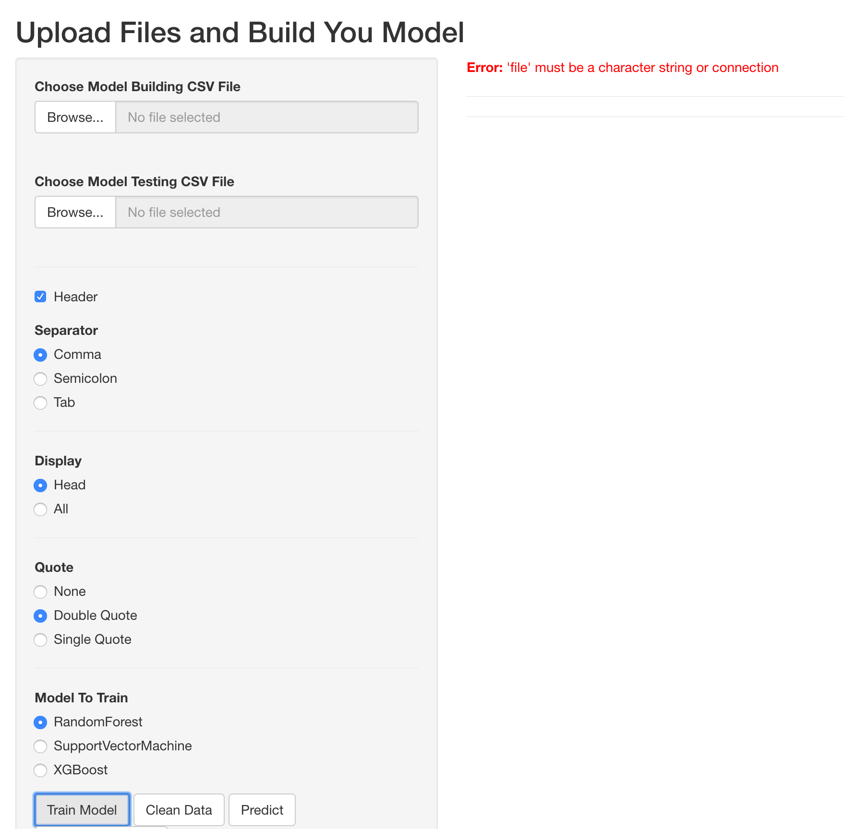

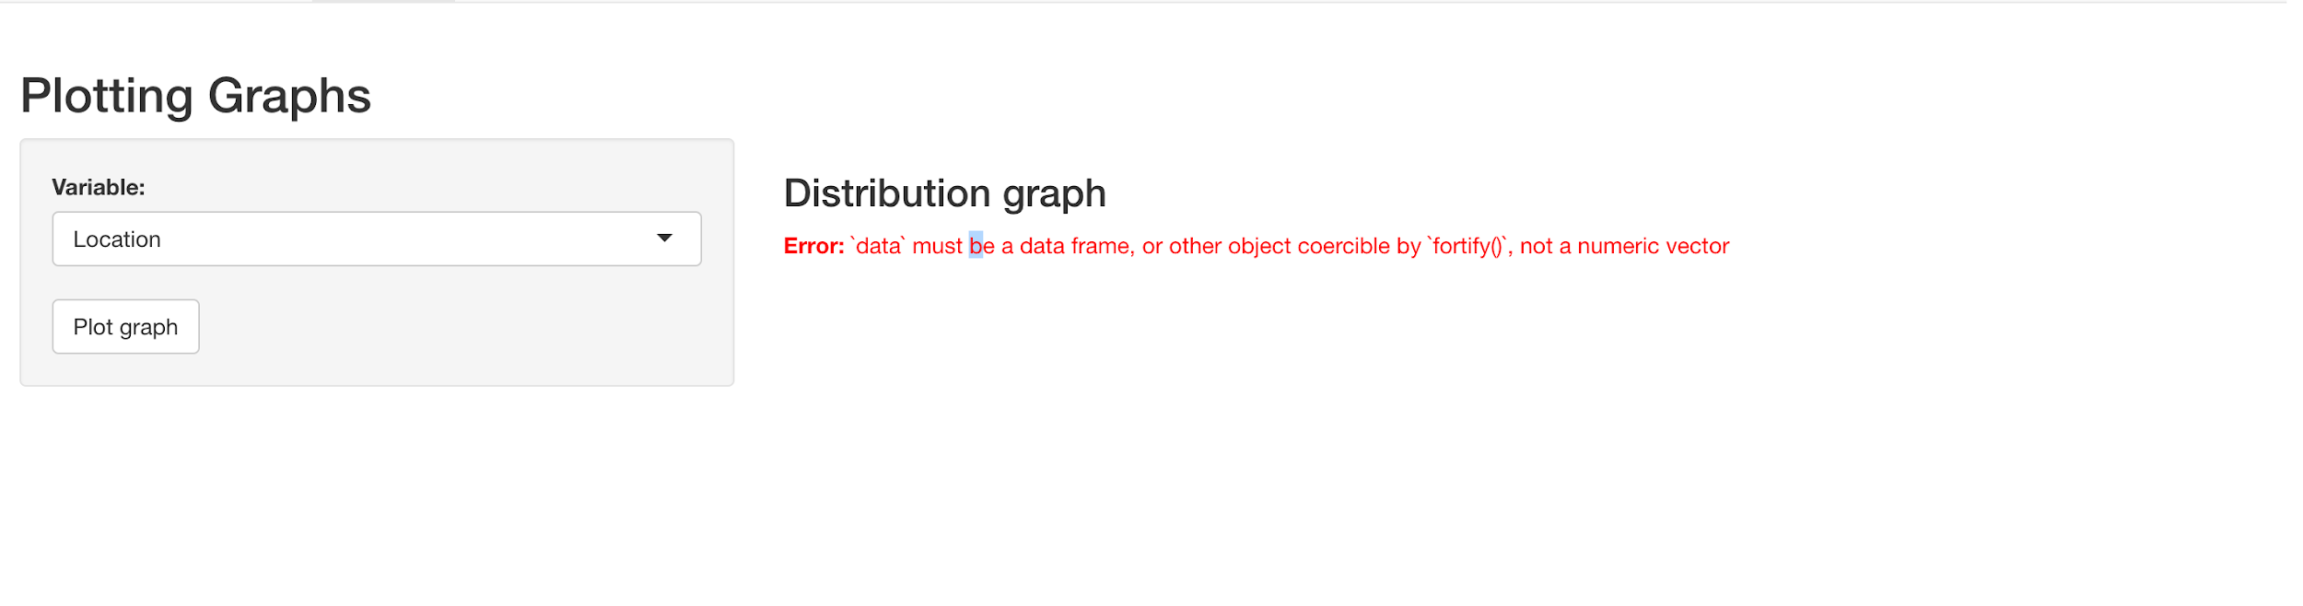

When the wrong type of files are inputted, an error will also show on the user interface.

The system is built so that it only works with CSV files.

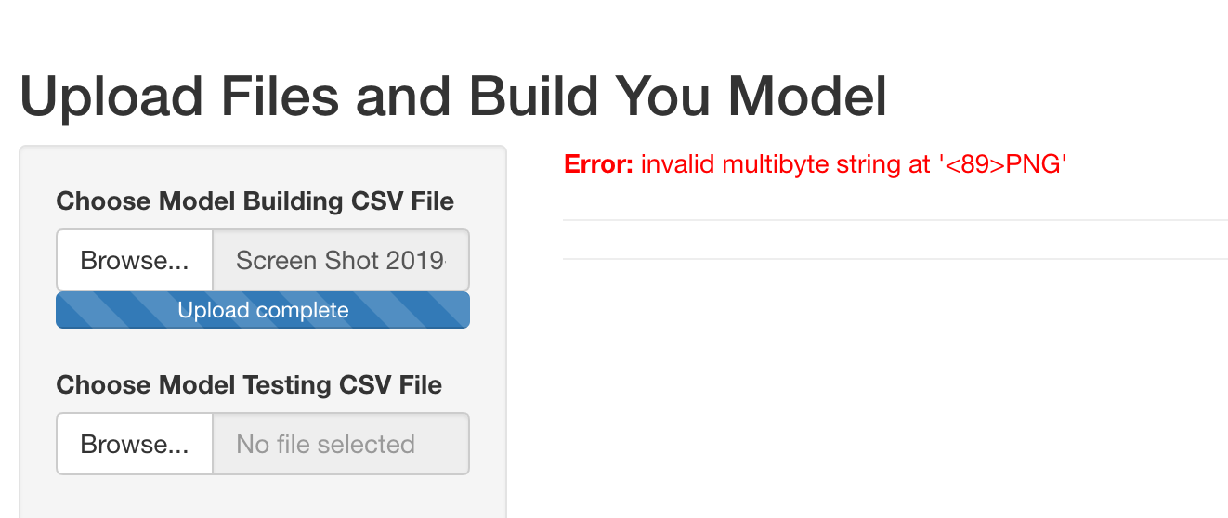

But when the input is csv files, since we have a specific formula, when the file does not have the specific columns that the model training need, it will also return an error saying that it could not find the corresponding column and it will not work.



The program is also built with a restriction of 30MB per file as the maximum file size.

A 30MB csv file would contain a lot of data and that would make our system run very slow, therefore we have at the moment capped the file size at 30MB. However, the restriction can be increased simply by changing the maxRequestSize.

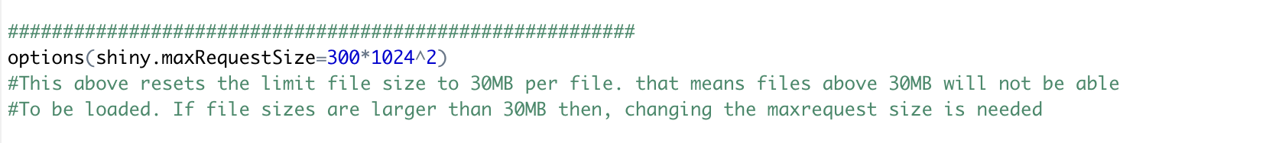

**Platform Dependencies:**

Currently, the software(User Interface) only works on MacBook, it does not work on windows. There are a few bugs that we have noticed on the windows operating system which prevents the software from working properly.



The error is from function Clean, where the test data are passed to the Clean function to clean and add raster data. It appears that on the windows operating system, the raster loading method does not work properly. Therefore the system will only be able to run on MacOS.

**Security:**

There are no security implemented in the system.

# Limitations and potential improvement

Model:

The models we have developed will not be able to predict any other species other than the given from the VBA data. There are a total of 6 species that the system can predict right now and the models are trained for those species only, so if a new species is introduced the models will not provide any prediction for it. The reason being, the species are predicted in relation to their own species model so when a new type of species is in the data set, no predictions will be provided.

Pseudo Absence Generation:

The method chosen for the pseudo absence data generation may not be the best way of generating absence data. Currently it is more or less likely to just be “random points”, which could mean that some generated points may be close to the actual presence points and thus it could affect the models’ ability to predict correctly. For improvement, we did have a second method in mind, which was the “2 degrees” away from the true presence method which has been proven that it will increase the accuracy of the pseudo absence data and thus providing the model with more accurate data.

Model Predictor:

The models we have developed may not be the best, the attributes used in the model development states were scrapped a lot of times due to the fact that the raster data does not provide a strong contribution to modeling when paired with the VBA attributes. Thus we decided to not use the attributes in the VBA data but to use the Raster data from the raster files to find connections between the Raster data and the VBA data. Therefore, the models may not be predicting accurately even though the prediction accuracy is high.

For improvement, if we could have found the Victorian Bioregion Shape file, we think it could provide a more suitable set of attributes. From the research we have done, we have found the set of regions where some of the species are known to exist however we were not able to find the Victorian Bioregion shape file online.

UI:

The system is very basic right now. We are not experts on developing user interfaces and this is the first time we have done something like this. We would like to provide an interactive map to the user if possible which would be more useful for the end user to look at and interact with. The current graphing method is rather “Useless” it is there to simply let the user physically see which points were predicted as reliable and which ones were unreliable. So for improvement, we could

# End user guide on the shiny app

Before we can use the shiny app please download the whole folder “FIT3164S2”

All material needed for running the shiny interface is in this folder.

(Also: If R and Rstudio is not downloaded on the computer, please download them here: <https://cran.r-project.org/bin/windows/base/> (R)

here: <https://rstudio.com/products/rstudio/download/> (R-studio) )

(Required libraries will be automatically reminded by R-studio, just click install when the reminder pops up)

Once both programs are downloaded, open up R-studio and on the top left, under the “File” tab navigate to “Open File”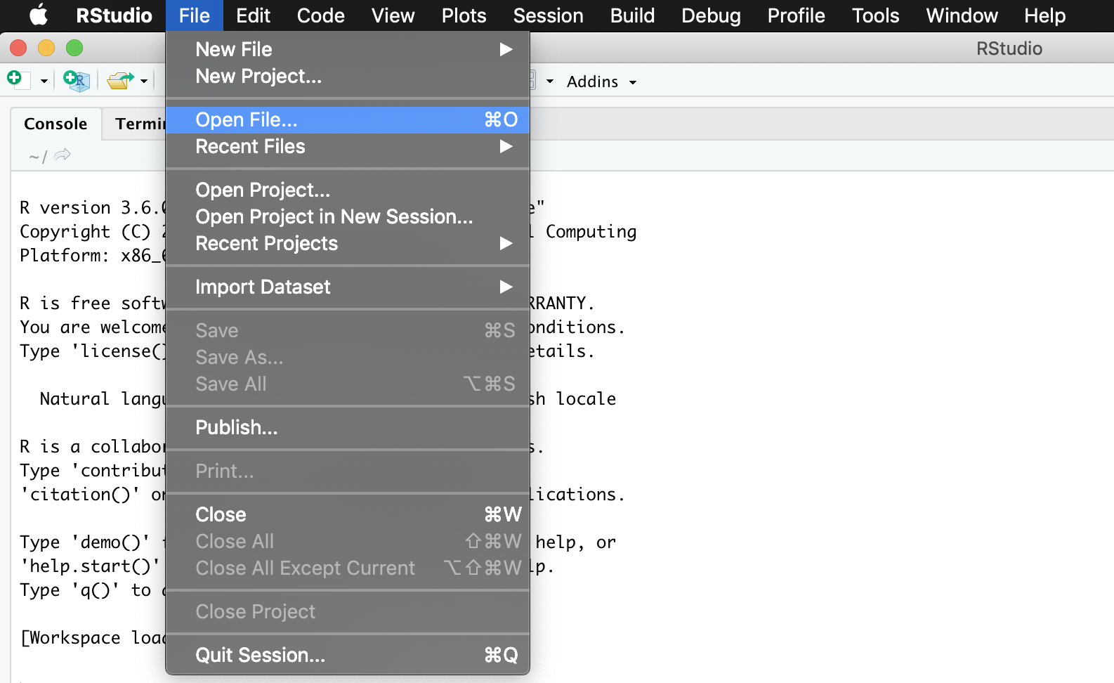

Then navigate to the “Shiny” folder inside “FIT3164S2” which you have downloaded, and inside the “Shiny” folder, choose “main.R”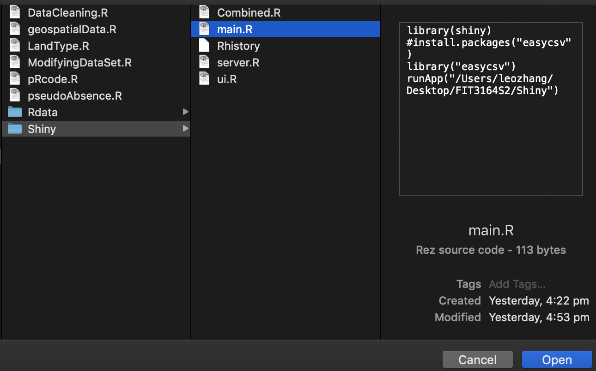

Once opened you should see something like this: 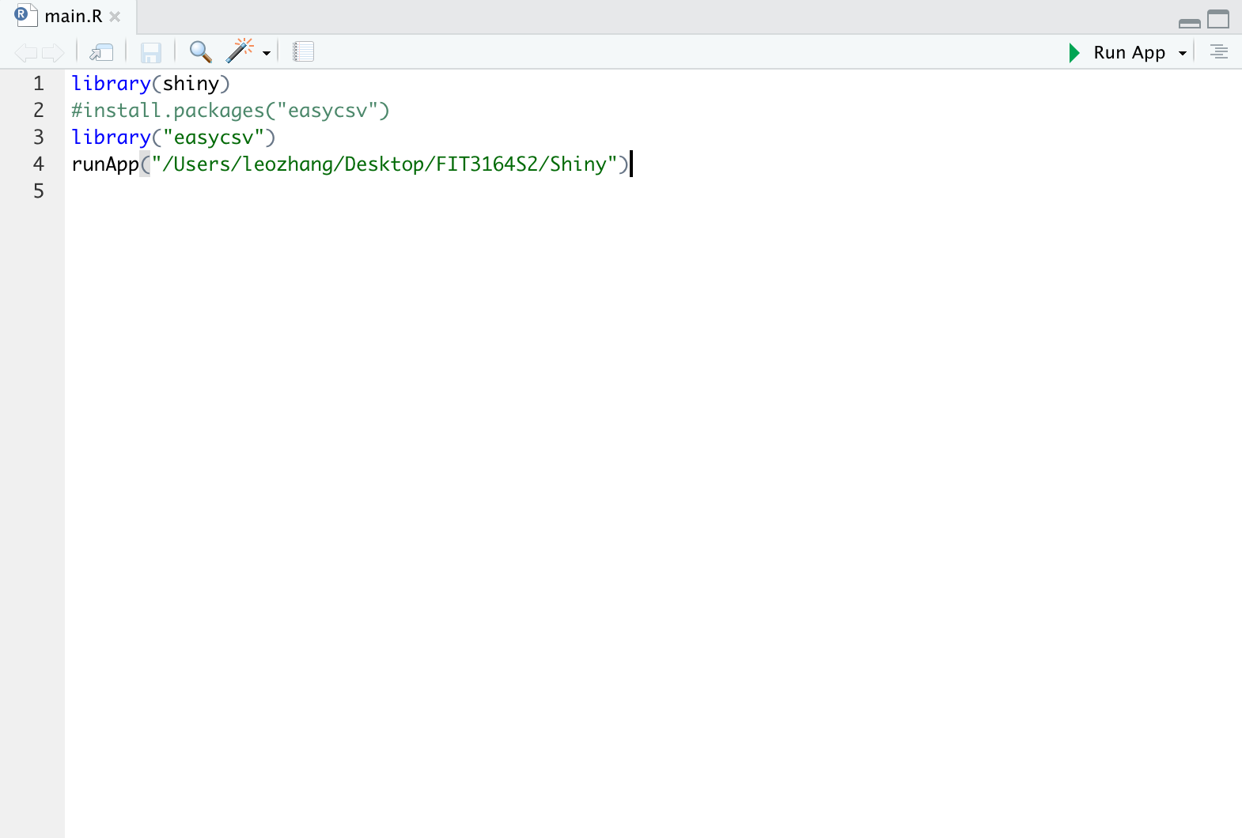

Now, press run app on the top right of the R script. (Red Cycle)

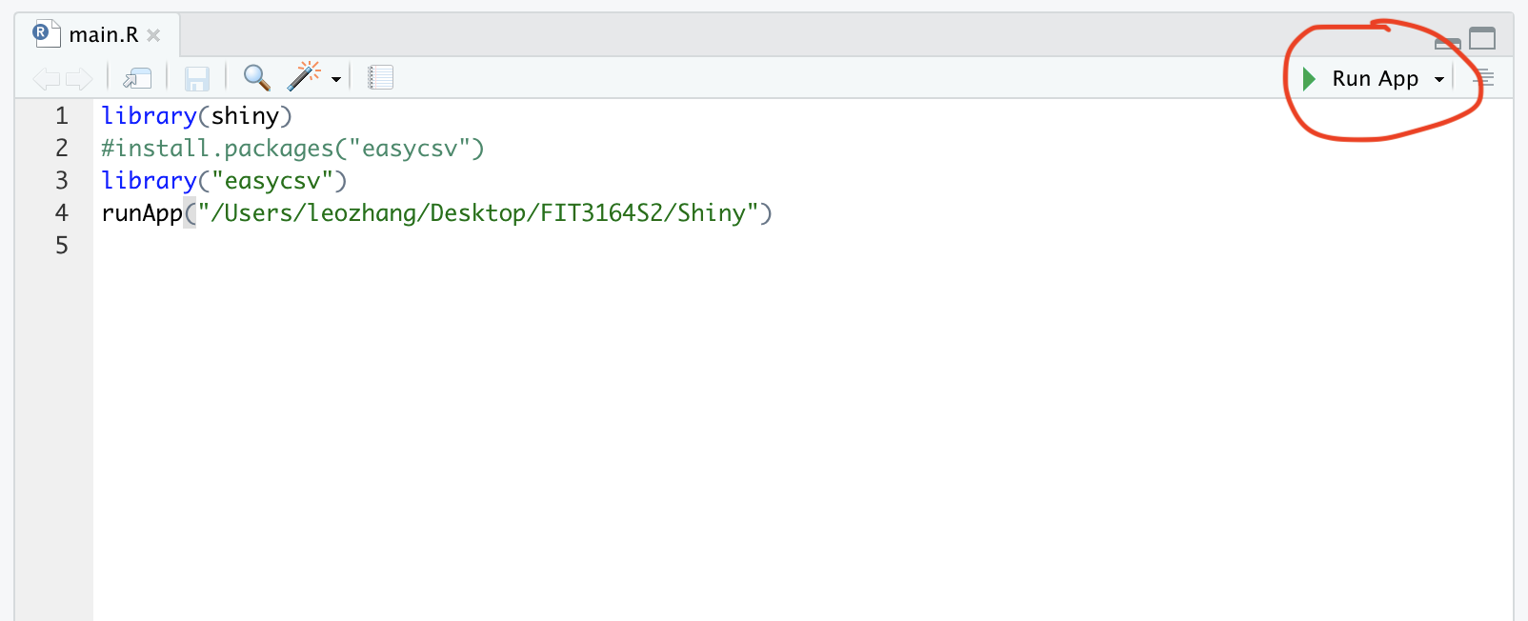

It should look something like the following:

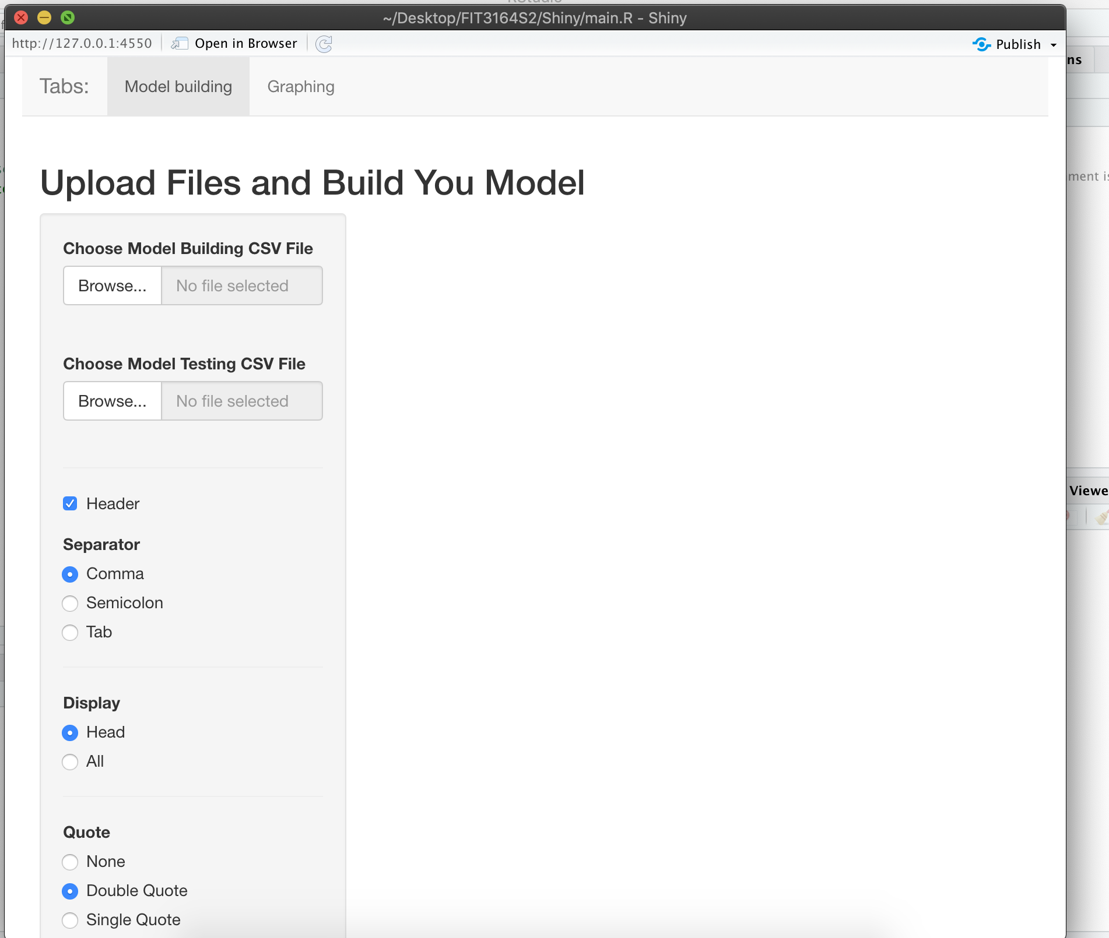

There are two menus

One is the Upload menu and the other is the Graphing menu

We are on the Upload menu right now and we can only do Graphing after we have our predicted data.

Now there’s two places for us to upload files:

The black circle is for us to upload the data that we have already modified and thus will be used for model training.

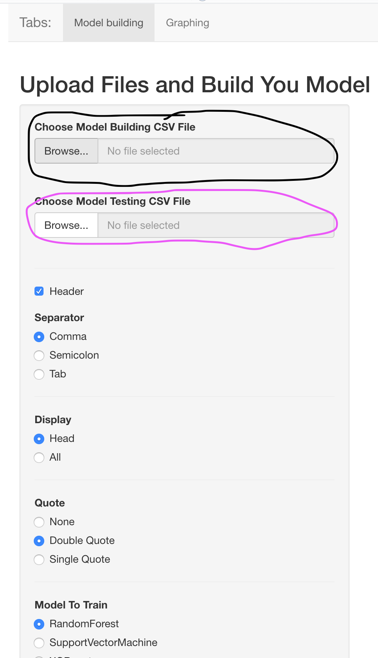

The purple place is for us to upload the new data that we want to classify/predict.

----------------------------------------------------------------------------------------------------------------

For the model training data, Navigate to “FIT3164S2” -> “Rdata” -> “Finalpseudo.csv”

And press open.

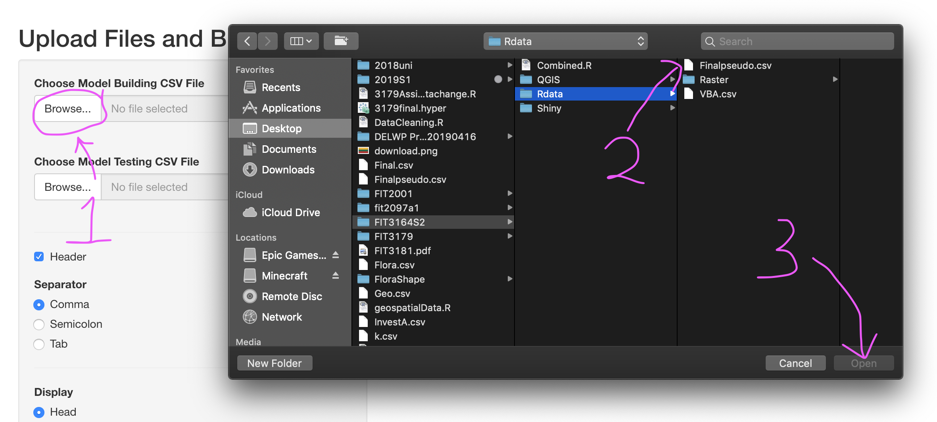

For testing purposes, we will use the original VBA data as our data for prediction/classification. (The VBA data is in the same directory)

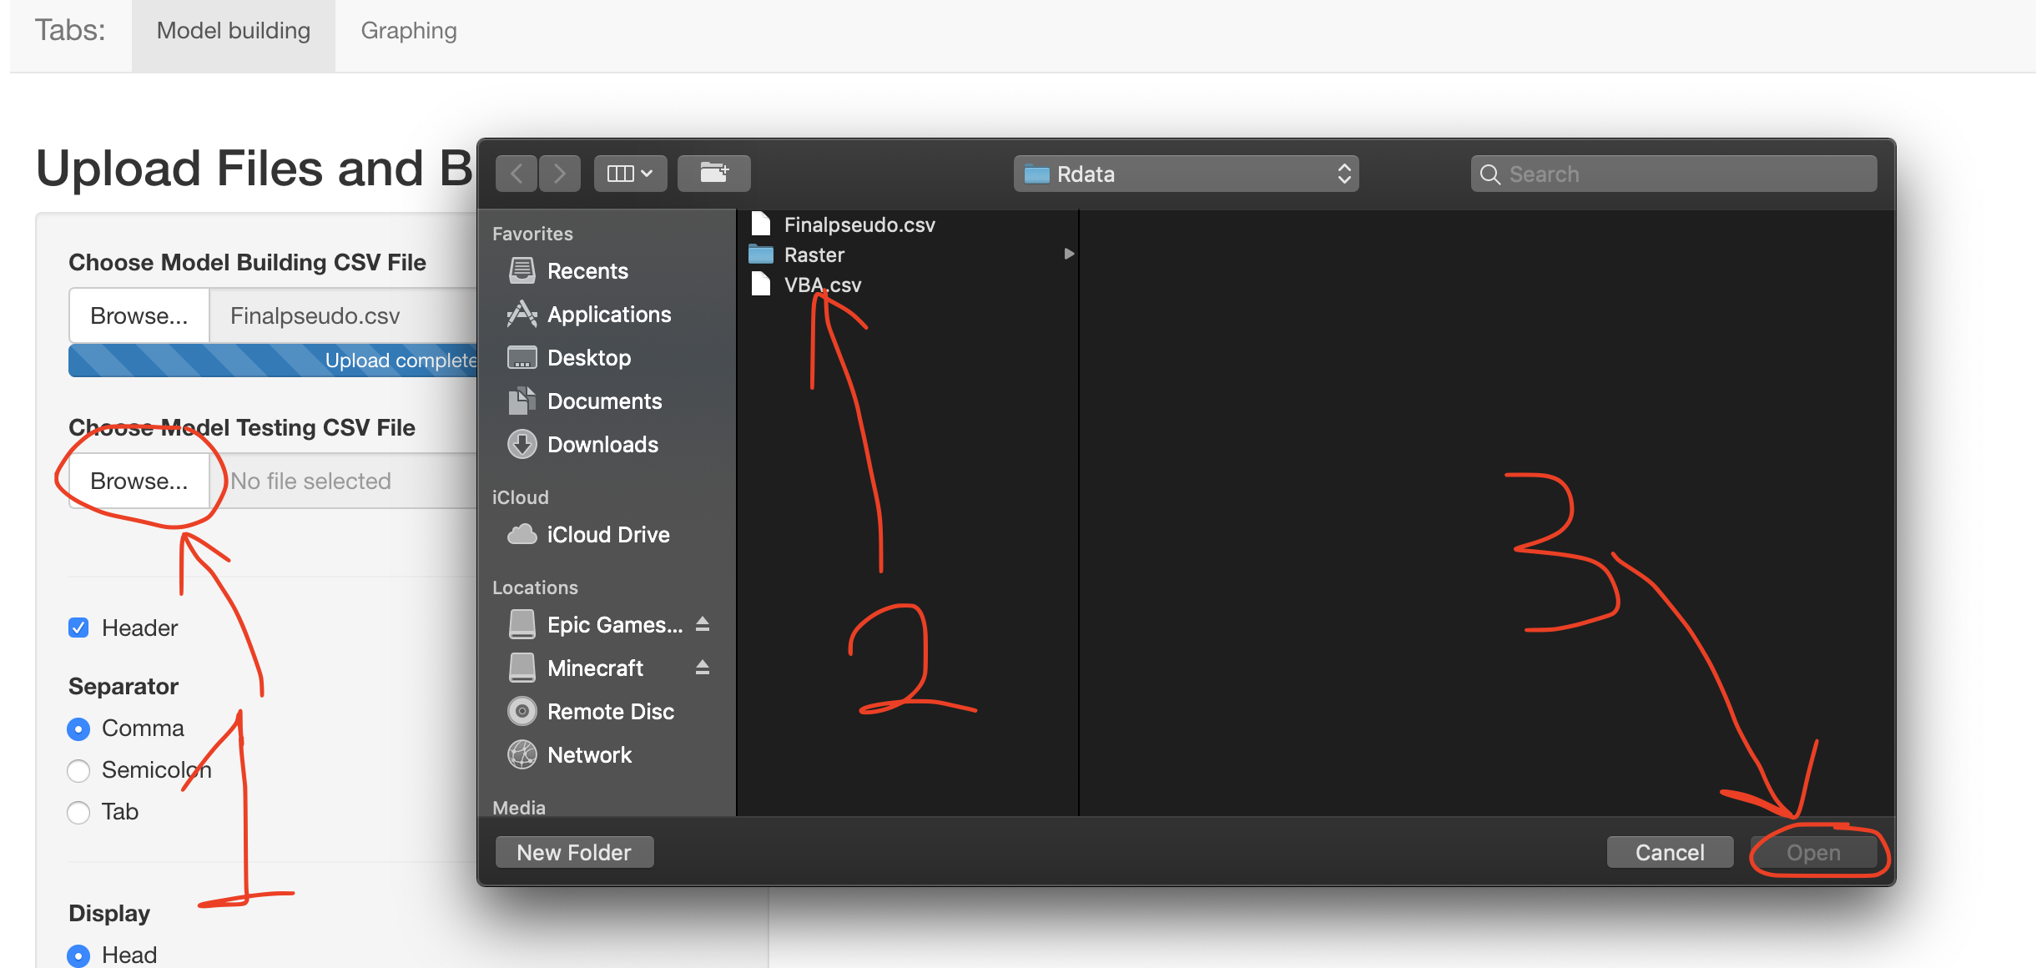

Once both files are loaded, it should look something like this:

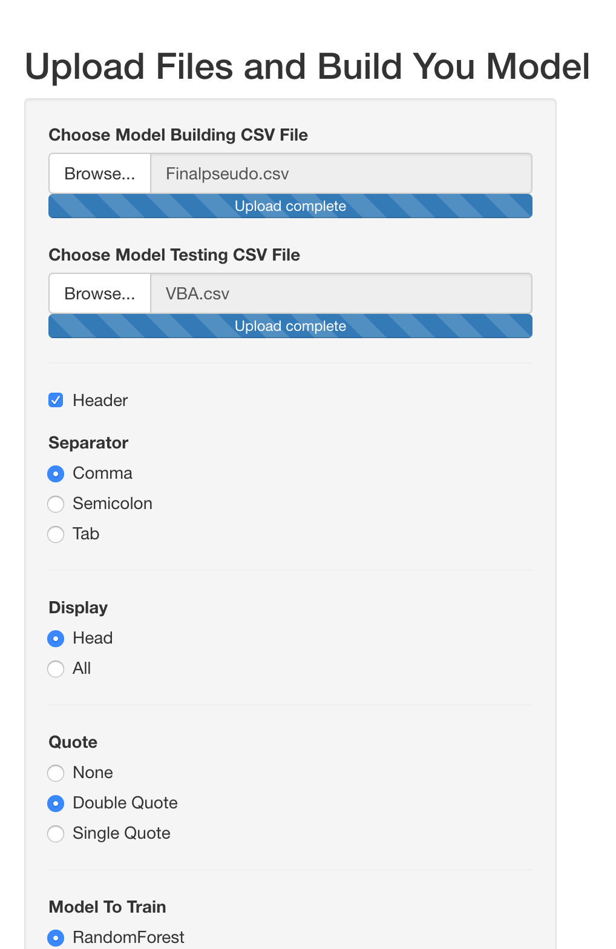

----------------------------------------------------------------------------------------------------------------

Now we are ready to Train the models, clean the data and also predict the data.

----------------------------------------------------------------------------------------------------------------

To train the model:

Choose a Model that you want to train (Blue circle)

Then

Simply press the Train Model button (Red circle) and you should see something as the following

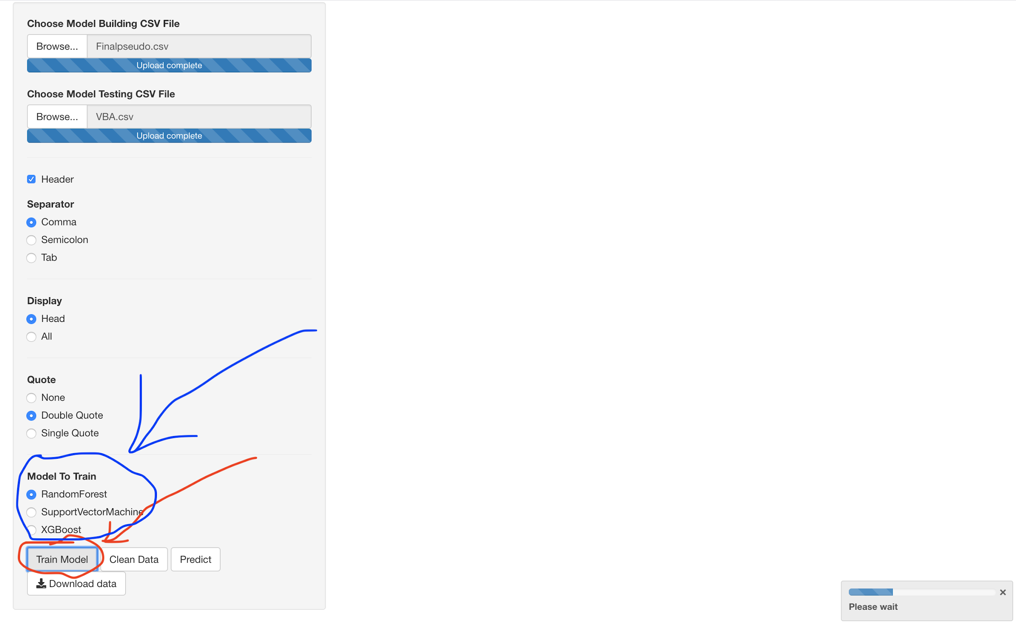

This will take a bit so please be patient…………

After it is done, it should look something like this:

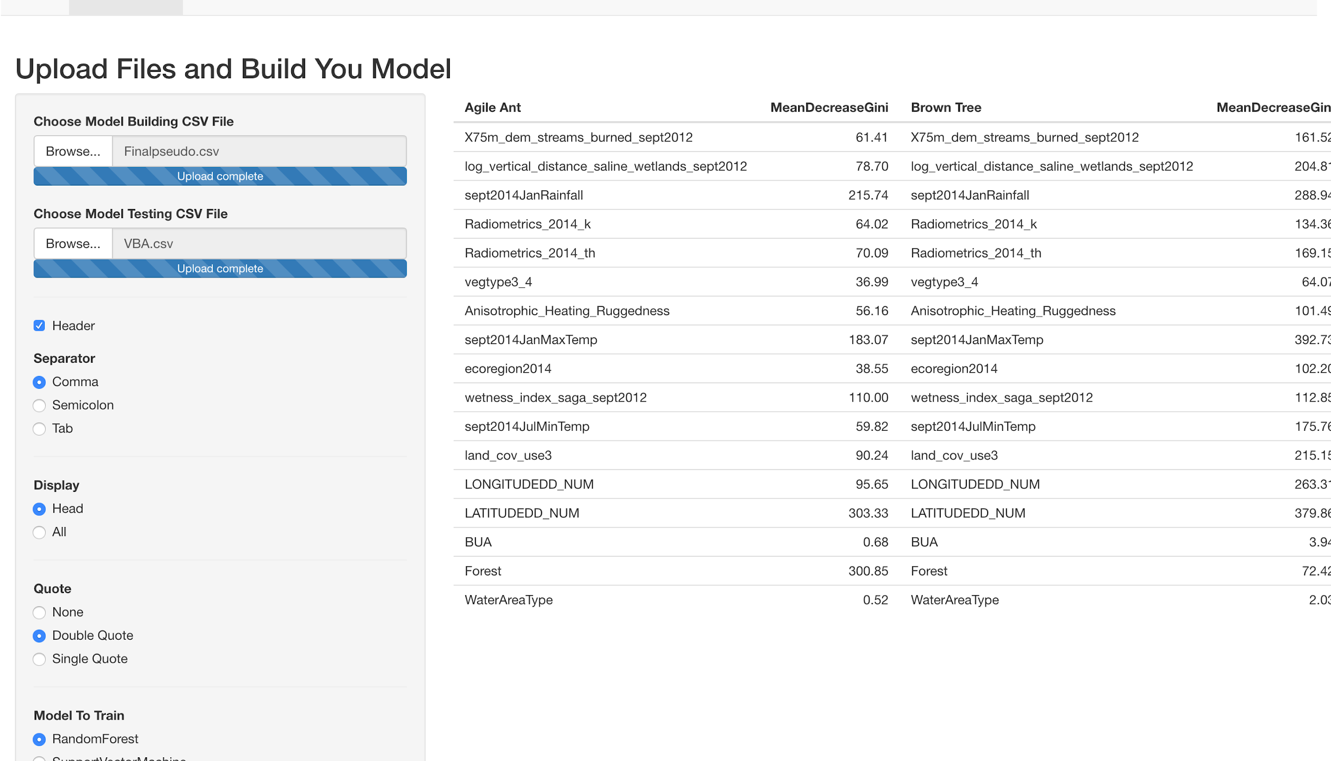

A table has appeared on the screen, the table actually shows the models attribute importance for each species, you can scroll to the right to see more:

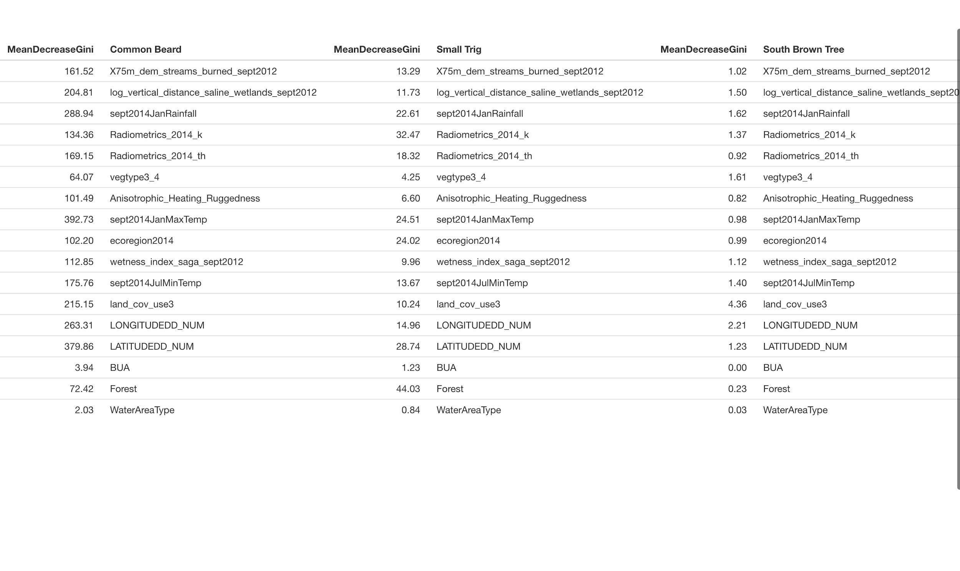

If you want to choose other models, just choose another model type and press train model again and it will automatically train that type of model for you.

Unfortunately, the model attribute importance for the SVM model type does not work, even though the models are trained, there will be no attribute importance shown.

----------------------------------------------------------------------------------------------------------------

Data Cleaning

----------------------------------------------------------------------------------------------------------------

Scroll back down to the button area and click on the Clean Data button

Once you have pressed the button, a window will pop out:

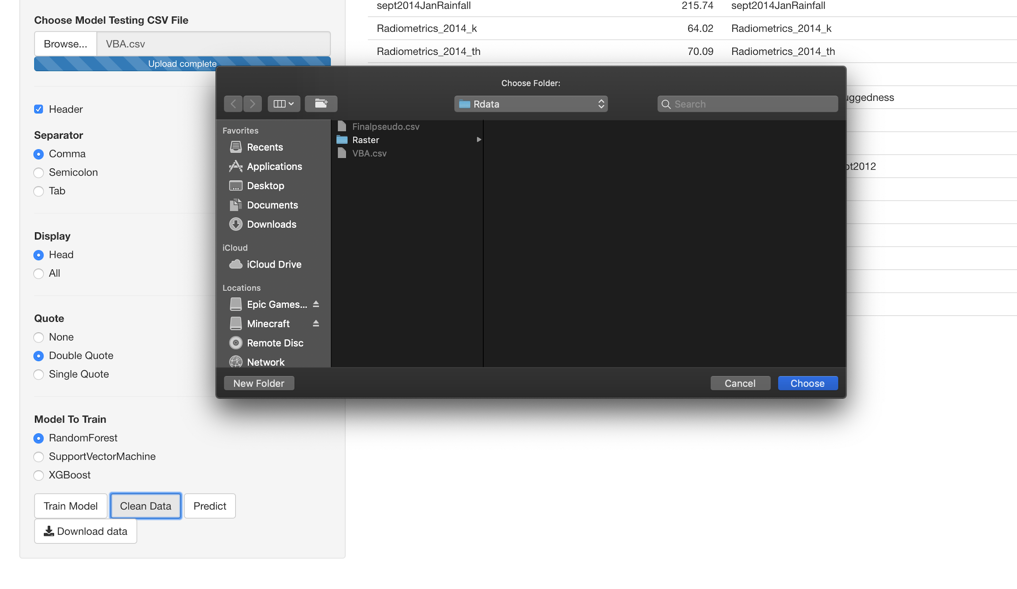

This window asks you to show it where the raster files directory is.

The raster files is in “FIT3164S2” -> “Rdata” -> “Raster”

(OR Follow the steps shown below)

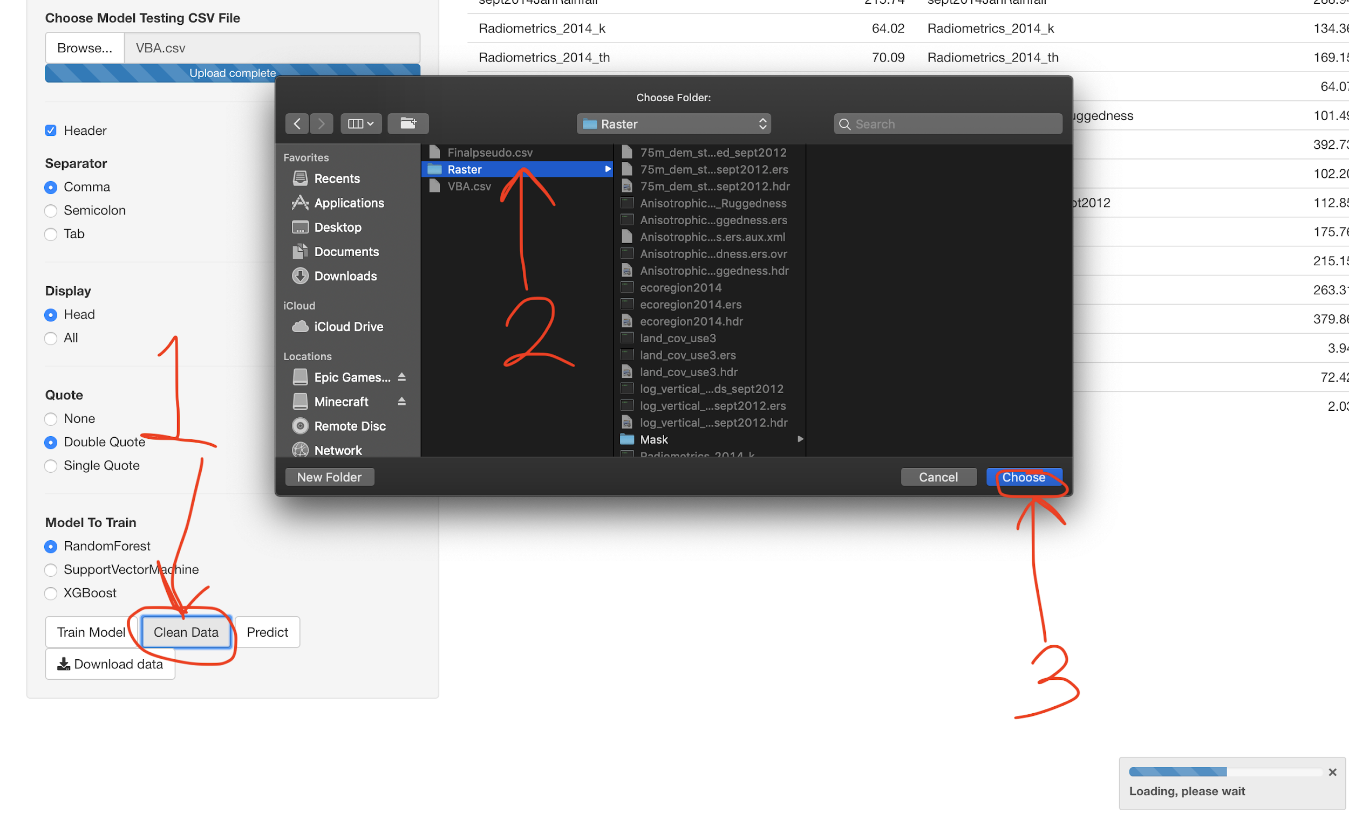

Once you have finished this step, it will take a while for the system to clean the data

Because it is reading all the raster files and shape files and extracting the information from them to the VBA data and also cleaning and turning the format of the data into something that can be used to generate models.

Once it has finished, another table will show at the top with the first 6 rows of data.

(Not showing more because the more rows of data it shows the slower the system runs)

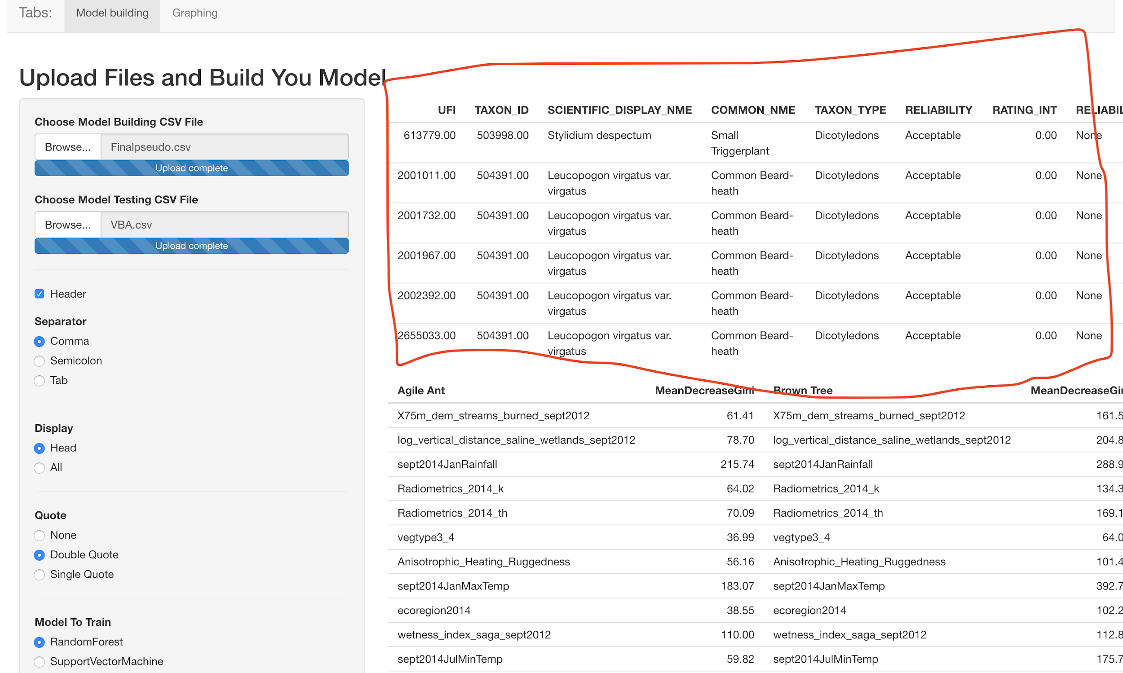

You can scroll to the right to see more:

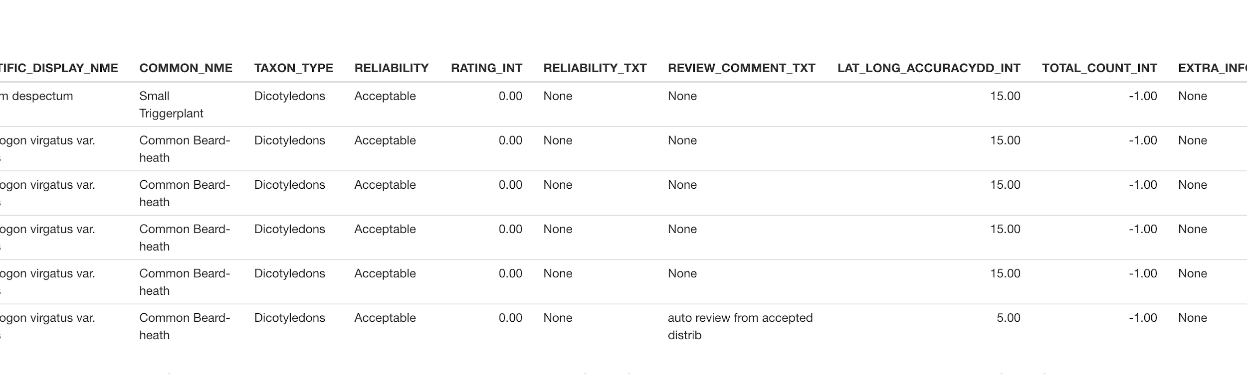

Otherwise, we are now done will data cleaning and the only steps left will be to predict and draw our graphs

----------------------------------------------------------------------------------------------------------------

Predicting

----------------------------------------------------------------------------------------------------------------

Scroll back to the bottom and press the Predict button

After a few seconds

A new table should be shown in between the two other tables:

(Red circle indicates the button)

(Red rectangle indicates the predicted value by the model)

(Blue rectangle indicates the VBA data)

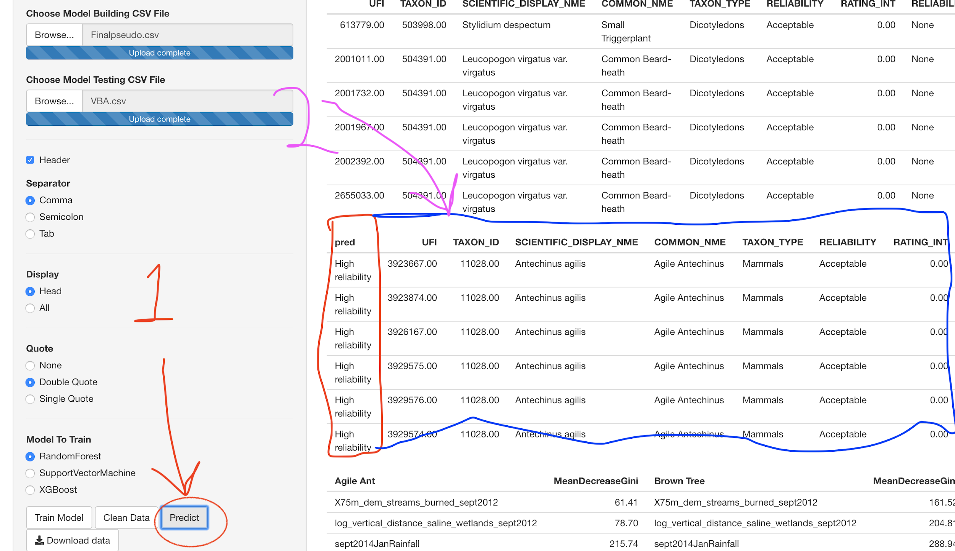

Now we have predicted the reliability of each of the rows in the VBA data.

We can now, use it to plot a graph and physically see which points have been predicted by our model to be reliable and which are unreliable

----------------------------------------------------------------------------------------------------------------

Graphing

----------------------------------------------------------------------------------------------------------------

Navigate to the top

On the top left you should see a Graphing tab:

Select the graphing tab:

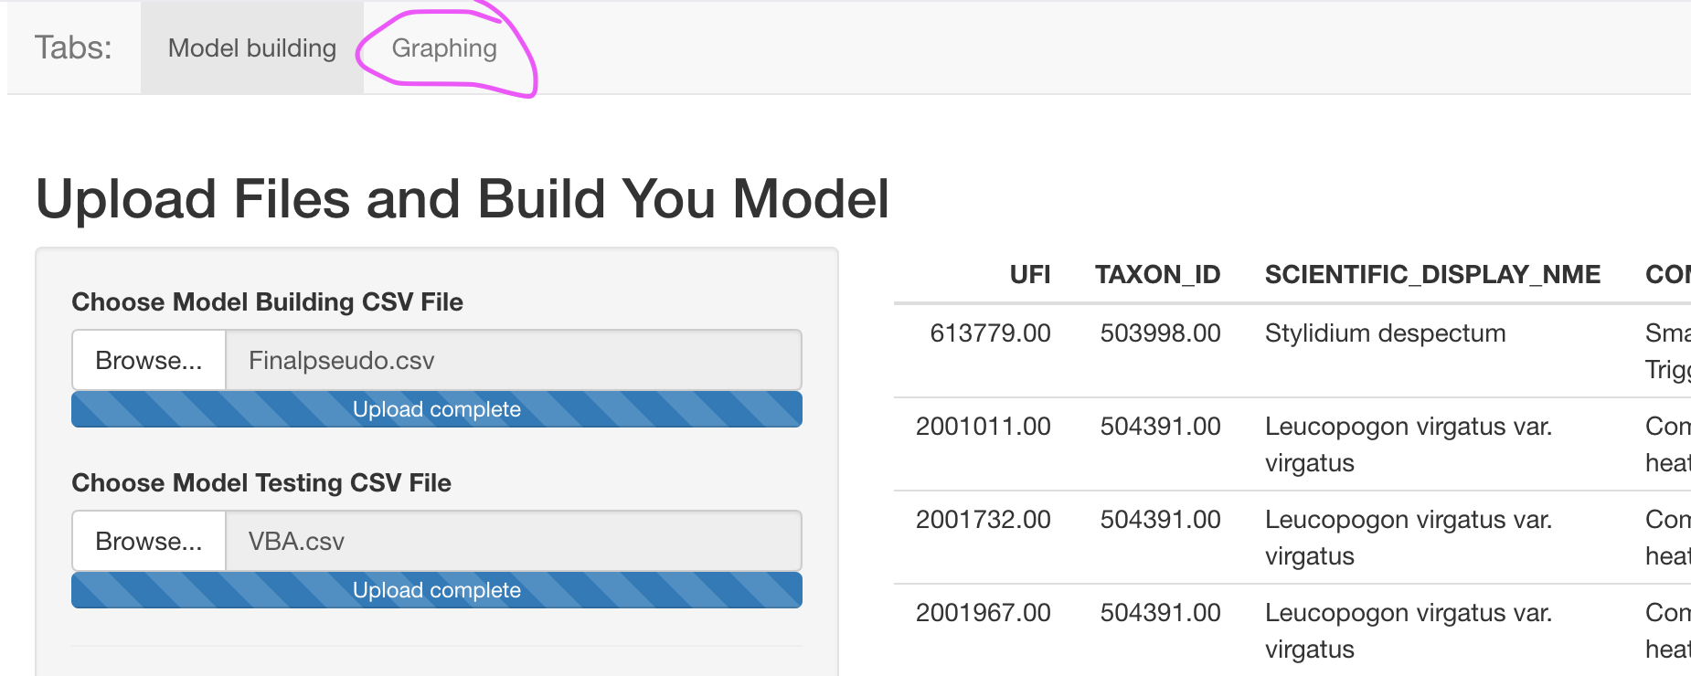

This page should show up

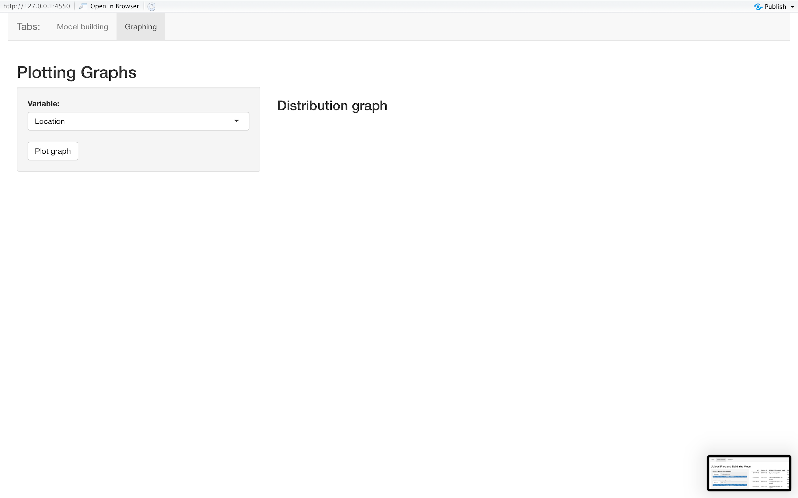

Press the Plot graph button to plot the Graph

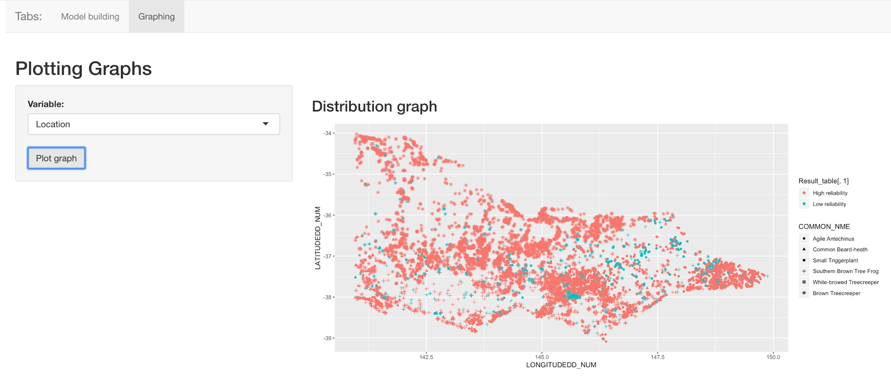

Now this shows which points were predicted as high reliability and which are low reliability.

This is not too useful as it does not allow interaction.

This graph is merely for the physical observation of the user.

The system also provide a Download function which the user can use to download the predicted data and do some further research for their own.

Navigate back to the Model Building tab at the top left

----------------------------------------------------------------------------------------------------------------

Downloading Data

----------------------------------------------------------------------------------------------------------------

Once you are back at the Model Building tab, on the left hand side, A download Data button should be there at the bottom:

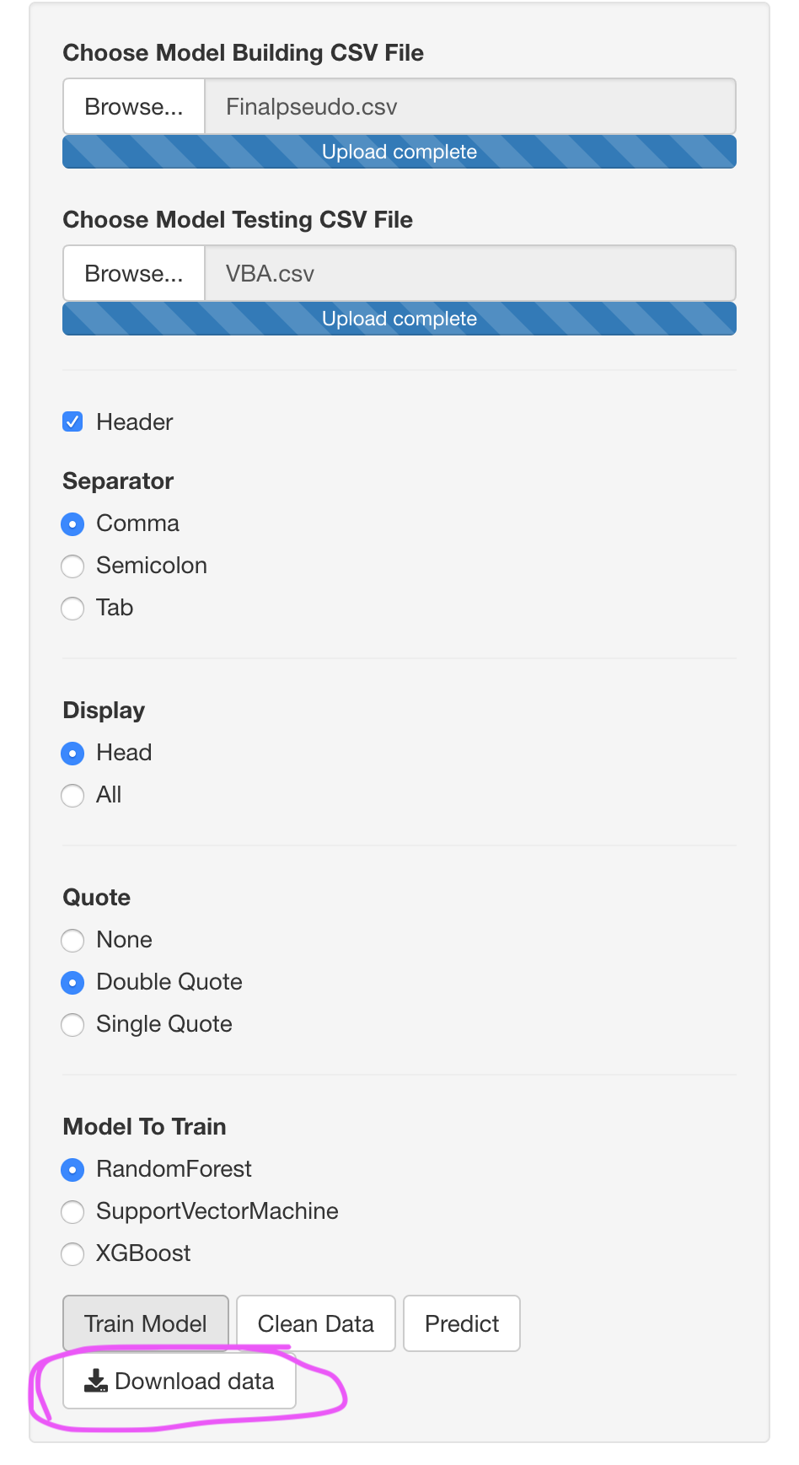

Press the Download Data Button and a window will pop up:

(It will ask for a directory where the user would like the files to be save)

Select the directory you want to save the file to: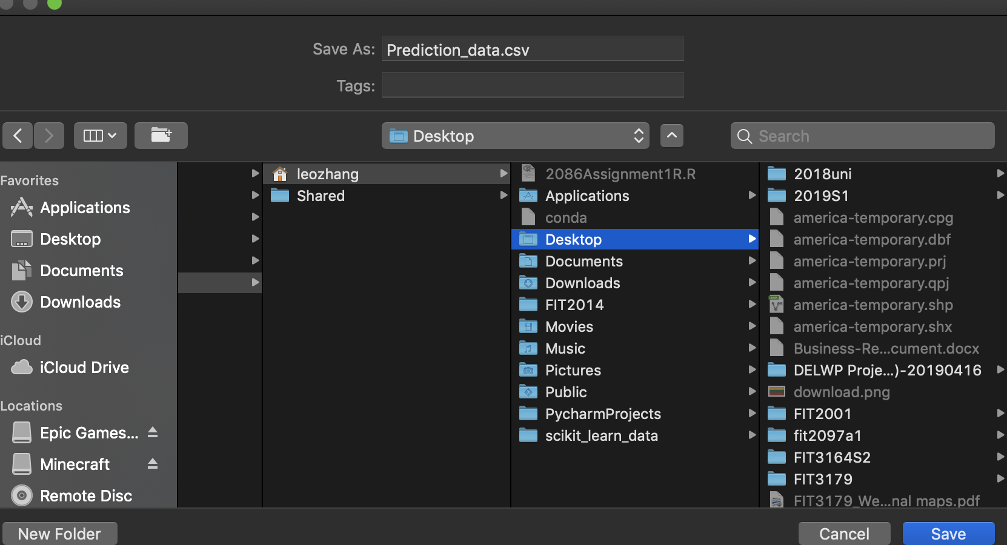

Press save, and the file should be at the target location and is ready to use for more exploration.

----------------------------------------------------------------------------------------------------------------

----------------------------------------------------------------------------------------------------------------

Extra Information

----------------------------------------------------------------------------------------------------------------

The steps to predicting data:

Upload both CSVs

|

|

Press Clean Data button

|

|

Choose Model type

|

|

Press Train Model button

|

|

Press Predict

|

|

Done

(After the Clean Data button has been pressed, it should not be pressed again)

Training other models do not need to clean data again

Simply choose another model type and then Press the Train Model Button to get New Models.

Remember: Predict only works when a Model has been trained and the Data has been cleaned

----------------------------------------------------------------------------------------------------------------

Thanks for reading.

# Technical User Guide

Download: <https://drive.google.com/open?id=13A_ISeSlKb1R3VcLI2l35dv3T5JCDp49>

**Configuration:**

(If R and Rstudio are not downloaded on the computer, please download them here: <https://cran.r-project.org/bin/windows/base/> (R)

here: <https://rstudio.com/products/rstudio/download/> (R-studio) )

After the download please open up R-studio.



Once opened, on the top left. Go to file and Open file

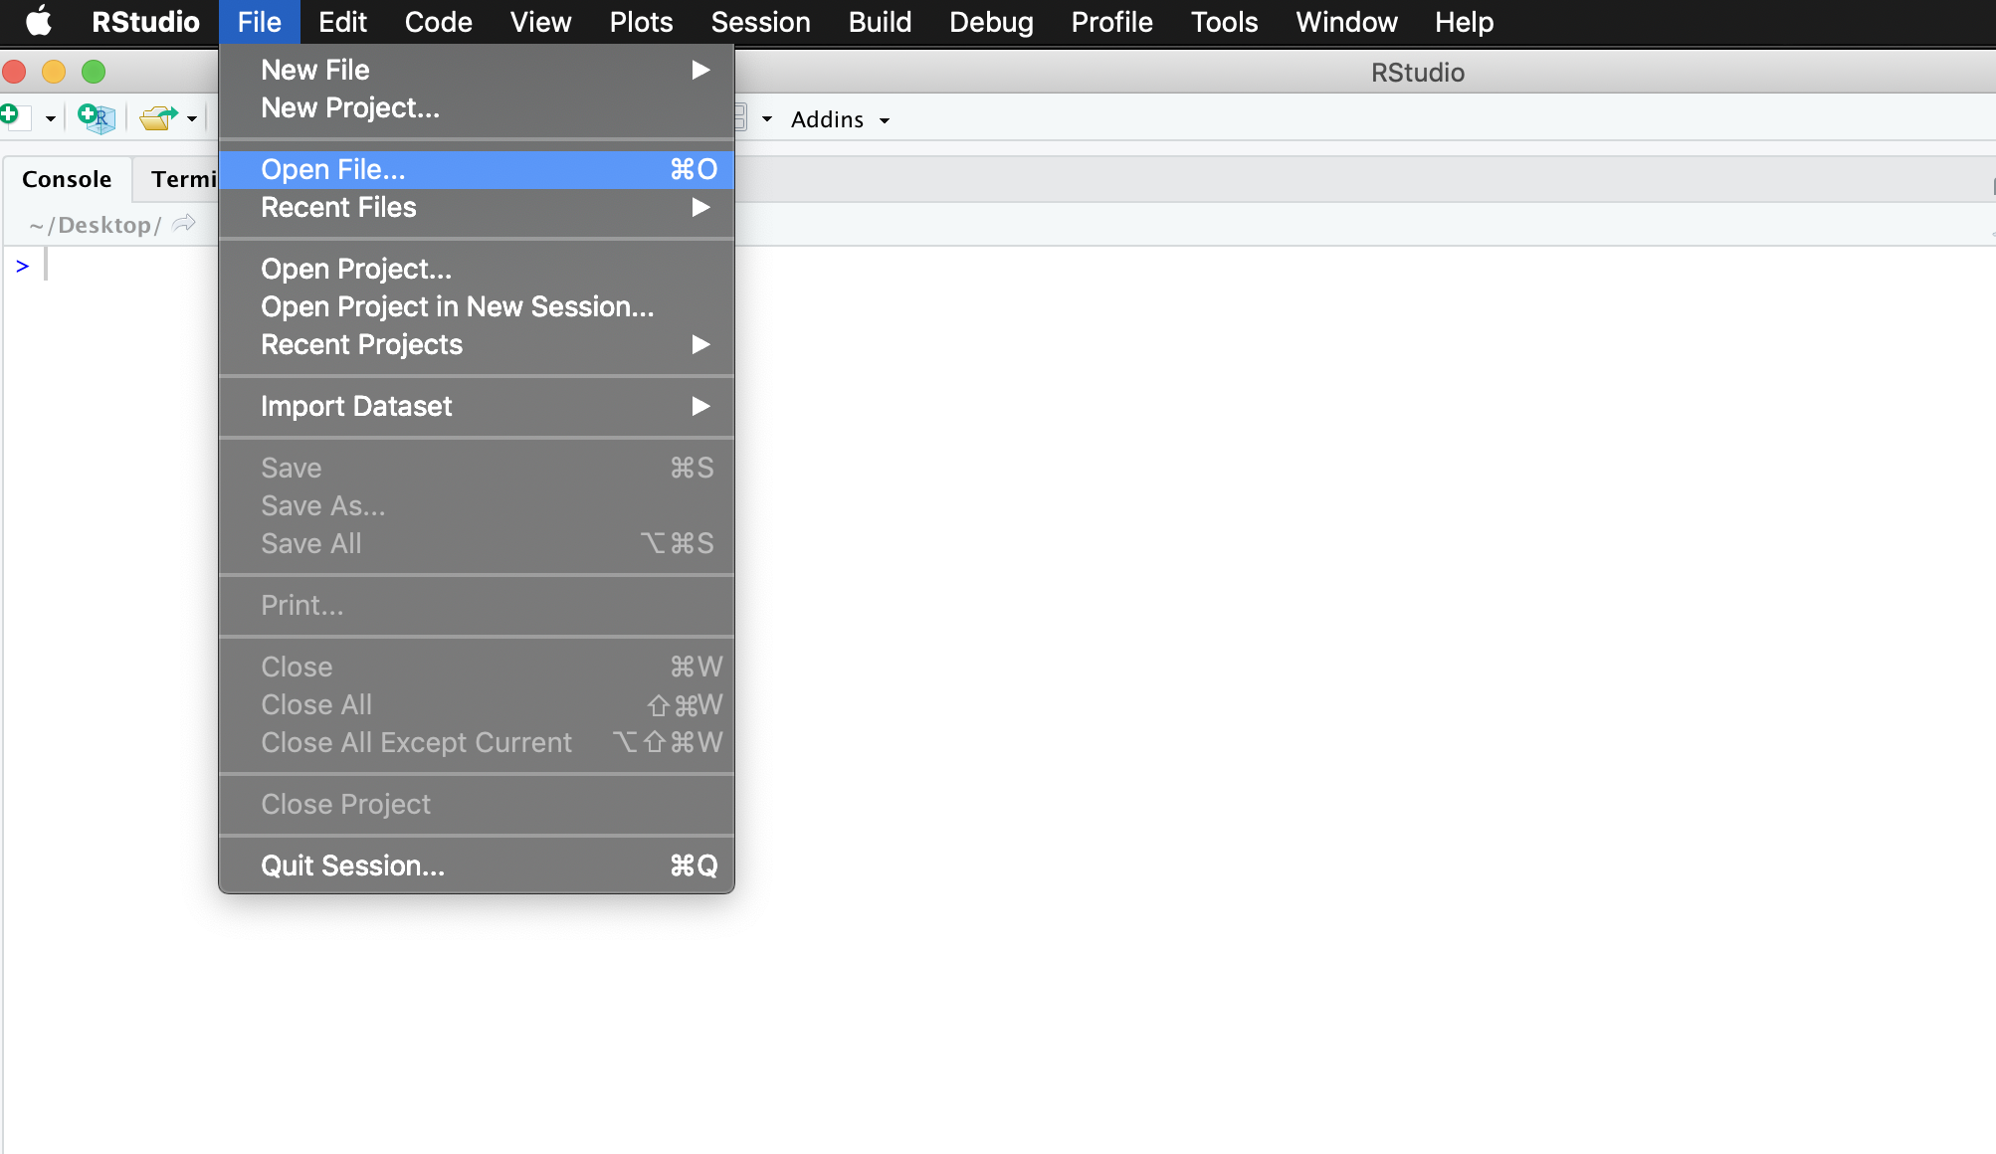

Navigate to the FIT3164S2 folder and then into the Shiny folder to select the main.R file to open

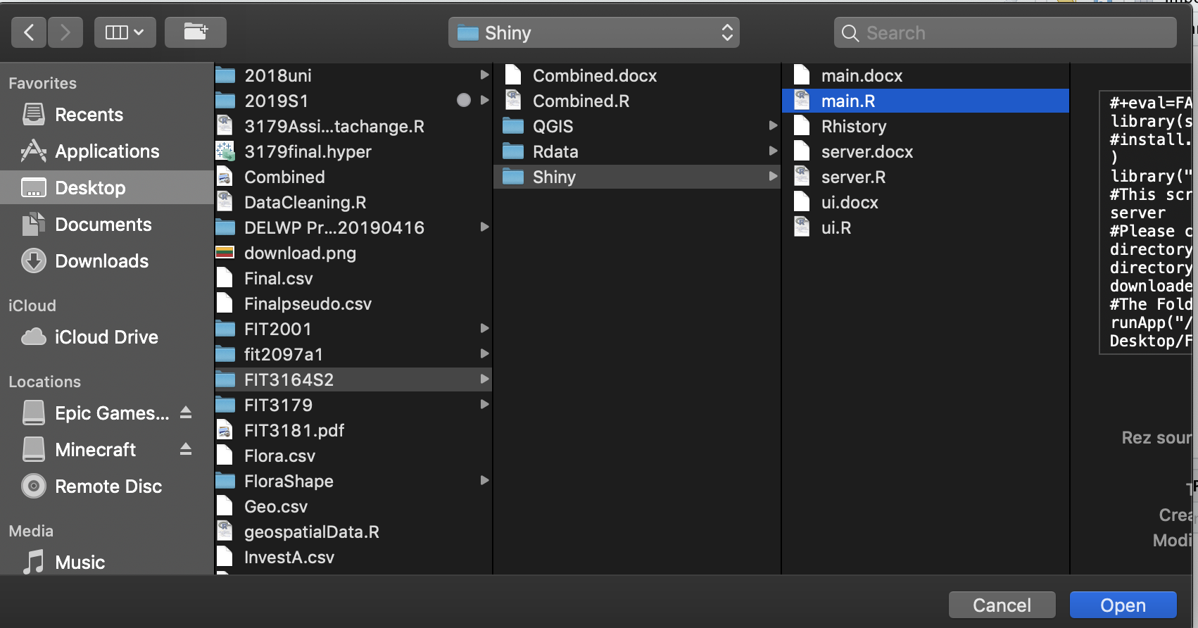

Once opened, it should show something like this: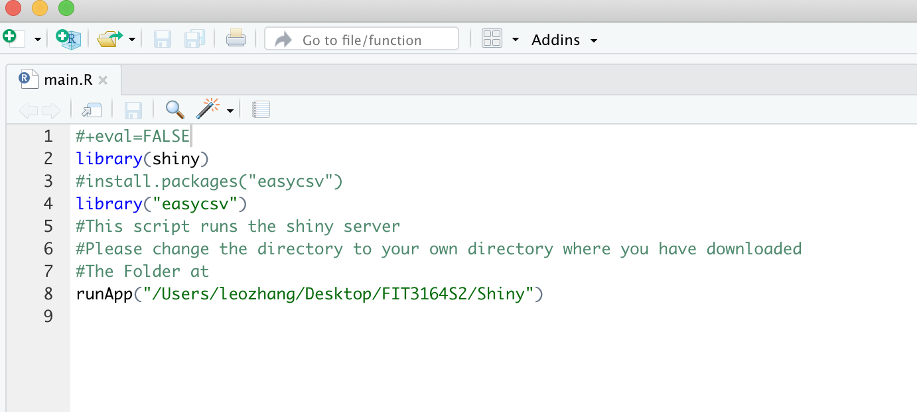

Now, change line 8 which is the runApp function.

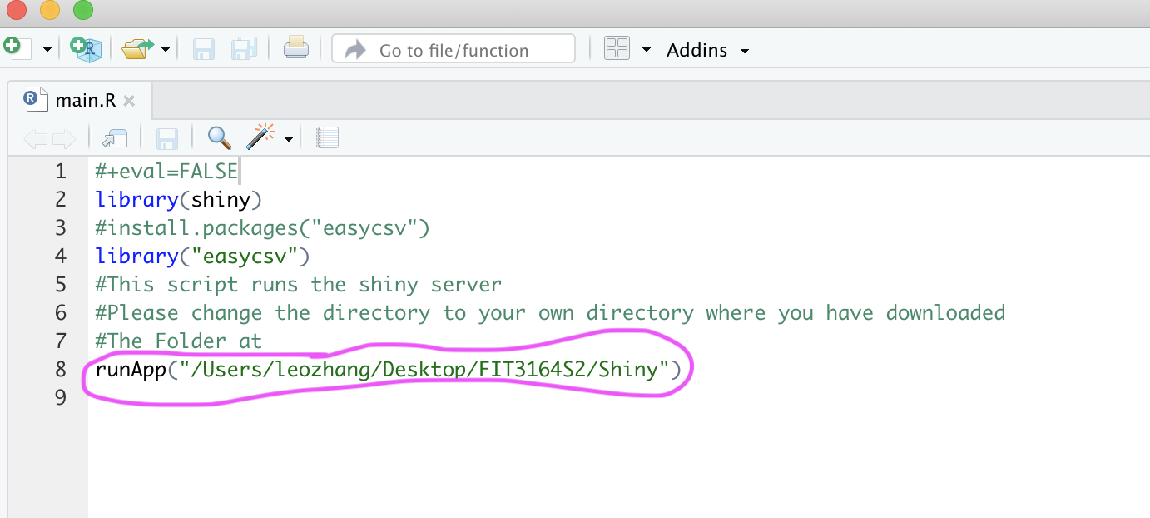

Change the directory that lays inside the function.

Example:

runApp(“~/Desktop/FIT3164S2/Shiny”)

The above line should work if the whole FIT3164S2 is at desktop, otherwise, navigate to where the specific path that the FIT3164S2 and Shiny folder is located.

After the directory has been changed, press runApp and it should all work.

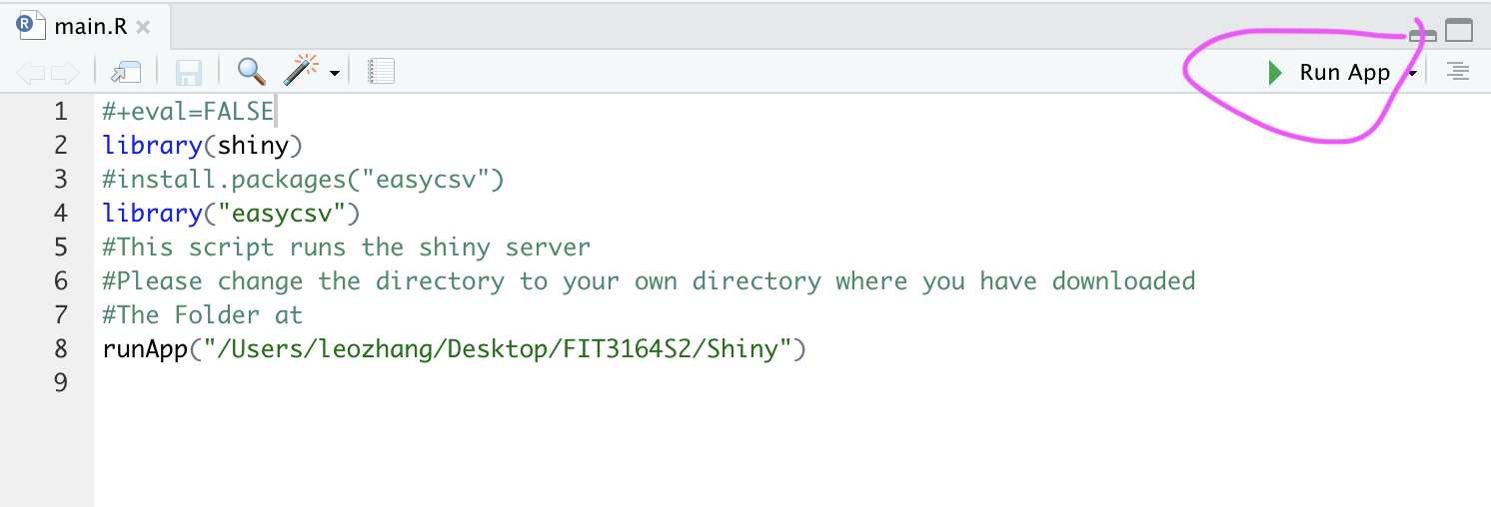

If the user want to predict more species, then please open the server.R and navigate to the modelBuilding function:

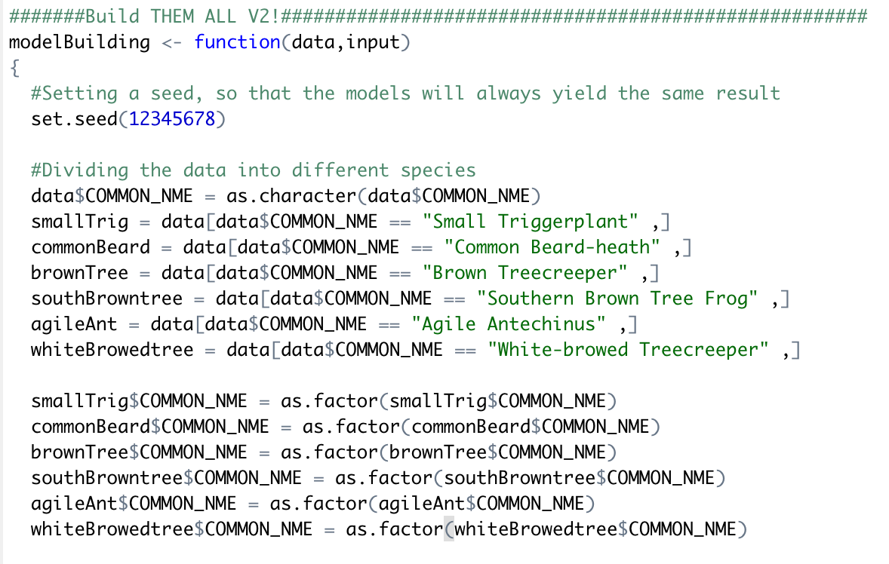

The user would have to manually insert the new species because in the system as it stands right now. The species are hard coded therefore it has to be manually be inputted. Also, on the combined.R which is used for preparing the Data that will be used for model training in our Shiny APP, the species has to be manually inputted.

This is the biggest limitation that we found, which is not every part is automated and thus it is not a very technical user friendly.

Next, please follow the End User Guide to guide you along the process it takes to produce the variable importances and the prediction from the models.